|  |  |  |  |  |
| --- | --- | --- | --- | --- |
|  |  | | |  |
|  |  | | |  |
|  | Function Group Spec  Driver Focused Mode  <<Feature>> (Allocated) | | |  |
|  |  |
|  |  |
|  |  | | |  |
| Document Type | **Function Specification** | | |  |
| Template Version | **6.0** | | |  |
| SysML Report Template Version | **O Beta (11/6/2019)** | | |  |
| Document ID | **functionspec_sysmlreporttemplate** | | |  |
| Document Location |  | | |  |
| Document Owner | **MyName** | | |  |
| Document Revision | **FGS0** | | |  |
| Document Status | **Draft** | | |  |
| Date Issued | **2021-03-09** | | |  |
| Date Revised | **2021-03-09** | | |  |
| Document Classification | GIS1 Item Number: | **27.60/35** | |  |
| GIS2 Classification: | **Confidential** | |
|  | | | | |
|  | | | | |
| Document Approval | | | | |
| Name | Role | | Email Confirmation | Date |
|  |  | |  |  |
|  |  | |  |  |

Auto-Generated by MagicDraw

Printed Copies are Uncontrolled

# Disclaimer

**This document contains Ford Motor Company Confidential information. Disclosure of the information contained in any portion of this document is not permitted without the expressed, written consent of a duly authorized representative of Ford Motor Company, Dearborn, Michigan, U.S.A.**

**Copyright, Ó 2016 Ford Motor Company**

This document contains information developed and accumulated by and for FORD MOTOR COMPANY. As such, it is a proprietary document, which, if disseminated to unauthorized persons, would provide others with restricted information, data, or procedures not otherwise available, exposing the FORD MOTOR COMPANY to potential harm.

Employees and suppliers having custody of this specification or authorized to use it must be cognizant of its proprietary nature and ensure that the information herein is not made available to unauthorized persons.

FORD MOTOR COMPANY reserves the right to protect this work as an unpublished copyrighted work in the event of an inadvertent or deliberate unauthorized publication. FORD MOTOR COMPANY also reserves its rights under copyright laws to protect this work as a published work.

This document or portions thereof shall not be distributed outside FORD MOTOR COMPANY without prior written consent. Refer all questions concerning disclosure to the author(s) or to any duly authorized representative of Ford Motor Company.

# Contents

1.1.1 Decomposition of 4

Disclaimer 16

Contents 17

2 Introduction 19

2.1 Document Purpose 19

2.2 Document Scope 19

2.3 Document Audience 19

2.3.1 Stakeholder List 19

2.4 Document Organization 19

2.4.1 Document Context 19

2.4.2 Document Structure 19

2.5 Document Conventions 20

2.5.1 Requirements Templates 20

3 Function Group Description 21

4 Functional Architecture 22

4.1 Description 22

4.2 Function List 22

4.3 Signal List 22

5 Function Specifications 23

5.1  23

5.1.1 Function Overview 23

5.1.2 Function Scope 25

5.1.3 Function Interfaces 26

5.1.4 Function Modeling 28

5.1.5 Function Requirements 28

6 Open Concerns 32

7 Revision History 33

8 Appendix 34

8.1 Data Dictionary 34

8.1.1 Logical Signals 34

8.1.2 Logical Parameters 34

8.1.3 Encoding Types 34

8.2 Glossary 34

8.2.1 Definitions 34

8.2.2 Abbreviations 35

**List of Figures**

Figure 1 Activity diagram “” depicting black box behavior collaboration 22

Figure 2: Activity Diagram of “” calling “” 26

Figure 3: 28

**List of Tables**

Table 1: - Decomposition Table 5

Table 2: Functions described in this specification 19

Table 3: List of Logical Functions 22

Table 4: Ford internal Documents 25

Table 5: Ford internal Documents *(not specified in model)* 25

Table 6: External documents and publications 25

Table 7: External documents and publications *(not specified in model)* 25

Table 8: Open Concerns *(Not supported by MagicDraw report generation.)* 32

Table 9: Definitions used in this document 35

Table 10: Abbreviations used in this document 35

# Introduction

## Document Purpose

The Function (Group) Specification (FS) specifies an individual function / a group of functions.

To get more information about the concept of feature, function and component level abstraction refer to the [Ford RE Wiki](http://wiki.ford.com/display/RequirementsEngineering/Requirements+Engineering+for+SW+Enabled+Features).

## Document Scope

The following set of functions from the [Global Feature & Function List](https://www.vsemweb.ford.com:443/tc/launchapp?-attach=true&-s=226TCSession&-o=ZmZNi0JHx3NrTDAAAAAAAAAAAAA) is described in this specification.

|  |  |  |  |
| --- | --- | --- | --- |
| **Function ID** | **Function Name** | **Owner** | **Reference** |
|  |  |  |  |

**Table 2: Functions described in this specification**

## Document Audience

The FS is authored by the owners of the individual functions. All Stakeholders, i.e., all people who have a valid interest in the functions and their behavior should read and, if possible, review the FS. It needs to be guaranteed, that all stakeholders have access to the currently valid version of the FS.

**#Hint:** The FS template has the IP Classification “Proprietary” by default. IP Classification “Confidential” might be required in some cases, e.g. by Ford Functional Safety.

### Stakeholder List

For the latest list of the feature stakeholder and their roles & responsibilities refer to <Put VSEM Link here>.

**#Hint:** Refer to [Ford RE Wiki – Stakeholder List](http://wiki.ford.com/display/RequirementsEngineering/Stakeholder+Analysis) on how to create a stakeholder list. The stakeholder list should be stored in VSEM in the pseudo folder “General Data Artifacts” of the corresponding function.

## Document Organization

### Document Context

Refer to the [Specification Structure page](http://wiki.ford.com/display/RequirementsEngineering/Specification+templates) in the [Ford RE Wiki](http://wiki.ford.com/display/RequirementsEngineering/Requirements+Engineering+for+SW+Enabled+Features) to understand how the FS relates to other Ford Requirements Documents and Specifications.

### Document Structure

The structure of this document is explained below:

**Section 1** – Introduction how to use this document including responsibilities and requisite documents. Explains the terminology. Gives a clarification of the definitions, concepts and abbreviations used in the document.

**Section 2** – Function Group Description. Gives an overview and the purpose of the function group.

**Section 3** – Functional Architecture: Specifies the overall functional architecture of the function group

**Section 4** – Function Specifications: Specifies the logical functions of the function group in detail

**Section 5** – List of Open Concerns

**Section 6** Revision history including a list of new or modified requirements. The requirements in this document are tagged, and this section contains different types of tables listing all, new, or changed requirements by their title and page no.

**Section 7** – Appendix: Presenting additional data mainly in a tabular form, e.g., a data dictionary

**#Hint:** All sections are mandatory, unless explicitly marked by the tag “#Classification” as “optional” or as applicable e.g. to certain domains like “Functional Safety”.

## Document Conventions

### Requirements Templates

Each requirement, use case or scenario in this specification shall follow the corresponding template given in the document template *Specification_Macros.dotm* at [RE Wiki - Specification Templates](http://wiki.ford.com/display/RequirementsEngineering/Specification+templates?src=contextnavpagetreemode).

#### Identification of Requirements

#### Requirements Attributes

The templates provided by *Specification_Macros.dotm* define a list of attributes for each requirement. This helps to classify the requirement. The attributes are explained at [RE Wiki - Requirements Attributes](http://wiki.ford.com/display/RequirementsEngineering/Requirements+Attributes?src=contextnavpagetreemode).

# Function Group Description

**#Classification:** Function Group only (remove section, if only a single Function is specified in this document)

**#Hint**: Provide an overview / a description of the Function Group

This Function Group consists of all functions allocated to 1207206812.jpg **Driver Focused Mode** <<Feature>> including all functions in their corresponding call trees.

Description of Driver Focused Mode:

Driver Focused Mode (DFM) is a feature that can be activated via customer input or the system automatically if the front passenger seat is unoccupied and minimize air flow to a front passenger seat. This is an approach to direct airflow to the driver by shutting off ducts, registers, and auxiliary units of the front passenger sides of the vehicle when it is unoccupied.

# Functional Architecture

**#Classification:** Function Group only (remove section, if only a single Function is specified in this document)

**#Hint:** The Functional Architecture shall reflect the result of the functional decomposition for a given feature or parts of it.

Refer to the [*RE Wiki – Functional Decomposition*](http://wiki.ford.com/display/RequirementsEngineering/Functional+Analysis+and+Architecture) for some guidance on how to decompose a feature into functions, i.e., how to find the right functional partitioning for the function level. The functions shown here are those, which are specified in section 5 “Function Specifications”.

## Description

**#Hint:** Provide some informal description of the characteristics of the chosen architecture. Also give some graphical representation of the Functional Architecture. Either SysML Internal Block diagrams or [Data Flow Diagrams](http://wiki.ford.com/display/RequirementsEngineering/Data+Flow+Diagram?src=contextnavpagetreemode) could be used to depict such a Functional Architecture.

**#Link:** [*SysML – Internal Block Diagrams*](https://pd3.spt.ford.com/sites/SystemsEngineering/SEC/sysml-teamsite/SysML%20Wiki/Internal%20Block%20Diagram%20Basics.aspx) or [*RE Wiki - Data Flow Diagrams*](http://wiki.ford.com/display/RequirementsEngineering/Data+Flow+Diagram?src=contextnavpagetreemodehttp://wiki.ford.com/display/RequirementsEngineering/Data+Flow+Diagram?src=contextnavpagetreemode)

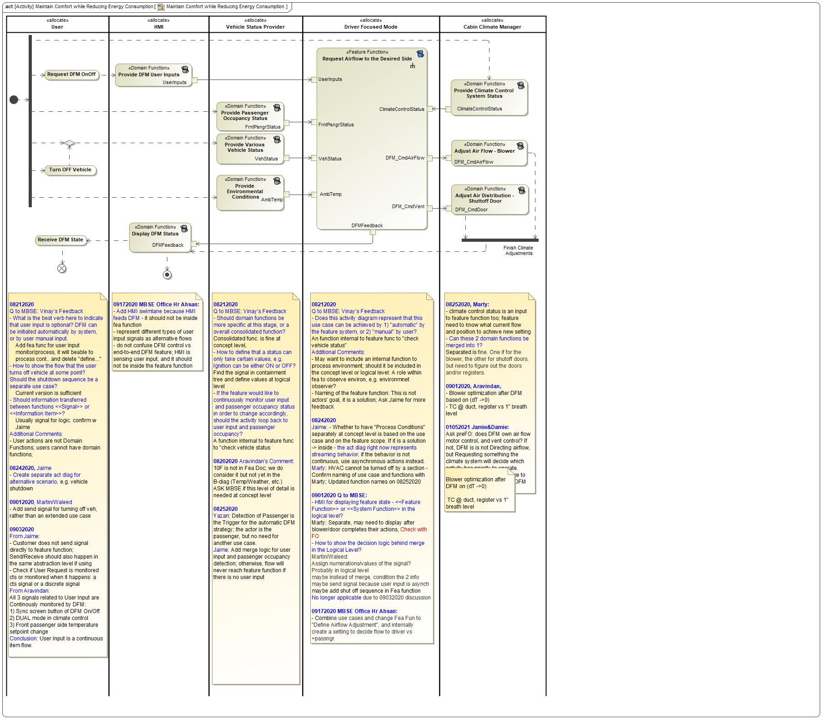

Figure 1 Activity diagram “Maintain Comfort while Reducing Energy Consumption” depicting black box behavior collaboration

## Function List

|  |  |  |  |
| --- | --- | --- | --- |
| **Function ID** | **Function Name** | **Function Description** | **ASIL** |
|  | 1693216511.jpg Process Climate System Inhibitors <<Subsystem Function>> | Subsystem Function "Process Climate System Inhibitors" shall set the output "DFMClimateCheck" to "Pass" or "Fail" indicating the pass or fail of the climate system inhibitor check, based on the input value of "ClimateStatus". |  |
|  | -1585998372.jpg Decide DFM Operation Mode <<System Function>> | Function "Decide DFM Operation Mode" shall set the output "DFMStateTarget" to "On" or "Off" based on the input values of: ambient temperature "AmbTemp", vehicle ignition status "VehStatus", user inputs "UserInputs", FrntPsngr seat occupancy "FrntPsngrStatus" and climate system status "ClimateCtrlStatus". The output "DFMStateTarget" is sent to downstream functions "Adjust Air to the Desired Side" and "Output DFM Feedback". |  |
|  | 1693216511.jpg Process Automatic Strategy <<Subsystem Function>> | Subsystem Function "Process Automatic Strategy" shall set the output "DFMReqAuto" to "On" or "Off", based on the input front passenger seat occupancy "FrntPsngrStatus" from the restraint control system. |  |
|  | 1693216511.jpg Determine Vent Shutoff Door Position <<Subsystem Function>> | Subsystem Function "Adjust Vent Shutoff Door Position" shall determine the shutoff door Open/Closed command "DFM_ShutoffDoorCmd" based on the input "DFMState". |  |
|  | 1693216511.jpg Configure Blower Compensation <<Subsystem Function>> | Subsystem Function "Configure Blower Compensation" shall calculate the proper blower compensation command based on the input "DFMState". |  |
|  | 34249308.jpg Request Airflow to the Desired Side <<Feature Function>> | "Direct Air to the Desired Side" feature function shall process various user inputs, front seat occupancy, vehicle status, and climate system status to determine the proper DFM operation mode. Based on the mode, the feature function shall output DFM feedback to HMI, a command for proper passenger side shutoff door position, and the command for proper blower speed. |  |
|  | 1693216511.jpg Arbitrate Mode <<Subsystem Function>> |  |  |
|  | -1585998372.jpg Request Air to the Desired Side <<System Function>> | Function "Adjust Air to the Desired Side" shall calculate the downstream control commands for the blower "DFM_BlowerCmd" and the FrntPsngr vent shutoff door "DFM_ShutoffDoorCmd", based on the input value of "DFMState". |  |
|  | 1693216511.jpg Determine Request <<Subsystem Function>> | Subsystem Function "Determine Request" shall set the output "DFMRequest" to "On" or "Off", based on the input values of "DFMReqManual" and "DFMReqAuto". |  |
|  | 1693216511.jpg Determine Inhibitors <<Subsystem Function>> | Subsystem Function "Determine Inhibitors" shall set the output "DFMInhibit" to "On" or "Off", based on the input values of "DFMVehCheck" and "DFMClimateCheck". |  |
|  | 1693216511.jpg Process Manual Request <<Subsystem Function>> | Subsystem Function "Process Manual Override" shall set the output "DFMReqManual" to "On", "Off" or "NoSelection" based on the input "UserInputs" from HMI system. |  |
|  | 1693216511.jpg Process Vehicle Enabling Conditions <<Subsystem Function>> | Subsystem Function "Process Vehicle Enabling Conditions" shall set the output "DFMVehCheck" to "Pass" or "Fail" indicating the pass or fail of the vehicle conditions check, based on the input values of ambient temperature "AmbTemp", and vehicle ignition status "VehStatus" from the vehicle status system. |  |
|  | 1693216511.jpg Output DFM Feedback <<Subsystem Function>> | Function "Output DFM Feedback" shall output HMI feedback "DFMFeedback" to user after "Adjust Air to the Desired Side" function has completed based on the input value "DFMState". |  |

Table 3: List of Logical Functions

## Signal List

Refer to the Data Dictionary - Logical Signals.

# Function Specifications

## 1693216511.jpg Arbitrate Mode

### Function Overview

#### Description

**#Hint:** Some descriptive text to explain the purpose and functionality of the function.

Function is allocated to:

* 1010756237.jpg Climate Controller <<Logical>>

No description provided for this function.

#### Variants

**#Classification**: Mandatory (State “Not applicable”, if not used)

**#Hint:** If different variants of the same function are specified in this section, list those variants in the table below.

Variants on Function level could be driven technology or feature content. Example: There could be a “Low Content” and a “High Content” variant of some exterior lighting function. The Low Content variant applies for Conventional Headlight technology, the High Content variant applies for LED and Xenon technology. In this case we call the different technologies the Variant Options (for the time being you could think of them as Logical Parameters) which the Variant depends on. The optional column “Variant condition” allows to express the dependency of a Variant based on Variant Options/Logical Parameters.

If requirements/signals are not applicable for all variants/variant options, those requirements should state explicitly, which function variant/variant option they apply to.

**#Link:** [RE Wiki – Variant Management](http://wiki.ford.com/display/RequirementsEngineering/Variant+Management).

*Not supported by MagicDraw report generation.*

#### Input Requirements

**#Classification**: Mandatory (State “Not applicable”, if not used)

**#Hint:** List any input requirements here (legal, Trustmark), which need to be taken into account, beyond what is specified in the corresponding Feature Documents.

*Not supported by MagicDraw report generation.*

#### Assumptions

**#Classification**: Mandatory (State “Not applicable”, if not used)

**#Hint:** A list of known assumptions concerning the effects of the function’s behavior on other functions or elements (i.e., dependencies) as well as assumptions on the behavior expected by the function (e.g. known limitations). During the course of the development most of those assumptions are typically either converted into actual requirements or discarded at some point – such that this chapter remains mostly empty.

No assumptions specified for this function.

#### References

##### Ford Documents

List here all Ford internal documents, which are directly related to the feature.

| **Reference** | **Title** | **Doc. ID** | **Revision** |
| --- | --- | --- | --- |
|  |  |  |  |

Table 5: Ford internal Documents *(not specified in model)*

##### External Documents and Publications

The list of external documents could include books, reports and online sources.

**#Hint:** You may refer to [IEEE Citation Reference](http://www.ieee.org/documents/ieeecitationref.pdf) on how to format a reference.

| **Reference** | **Document / Publication** |
| --- | --- |
|  |  |

Table 7: External documents and publications *(not specified in model)*

#### Glossary

See Appendix for Definitions and Abbreviations.

### Function Scope

The 1693216511.jpg **– “Arbitrate Mode”** function is called by the following functions:

* -1585998372.jpg – “Decide DFM Operation Mode”

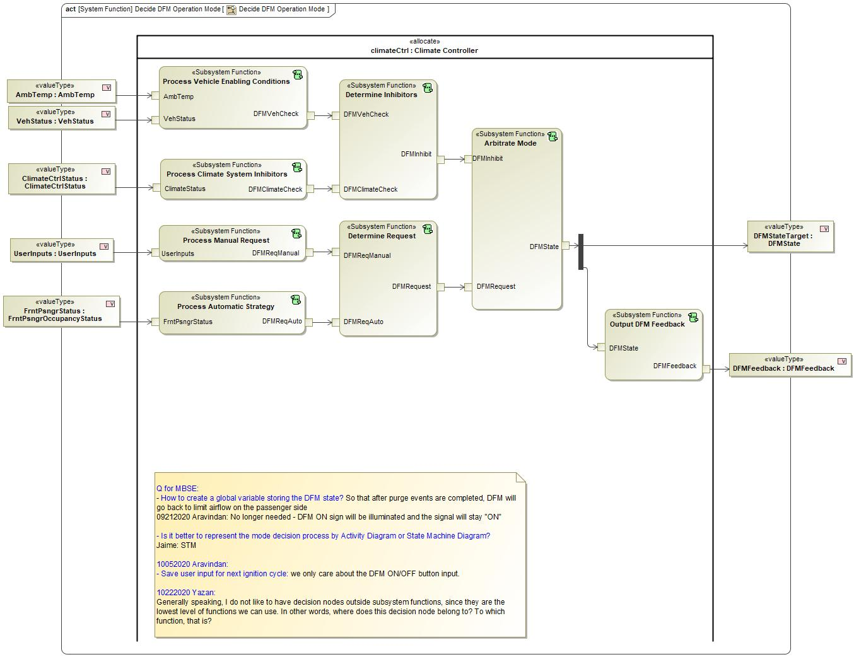

Figure 2: Activity Diagram of -1585998372.jpg “Decide DFM Operation Mode” calling 1693216511.jpg “Arbitrate Mode”

### Function Interfaces

**#Link:** [RE Wiki – Adding a Logical Signal or Parameter](http://wiki.ford.com/display/RequirementsEngineering/Adding+a+Logical+Signal+or+Parameter)

#### Logical Inputs

|  |  |
| --- | --- |
| **Signal Name** | **Description** |
| DFMRequest  Type:  -1346609435.jpg DFMRequest | Signal Description:  Logical signal indicating DFM is requested to be On/Off regardless of method  Received from:   * 1693216511.jpg Determine Request |
| DFMInhibit  Type:  -1346609435.jpg DFMInhibit | Signal Description:  Logical signal indicating whether DFM is inhibited  Received from:   * 1693216511.jpg Determine Inhibitors |

#### Logical Outputs

|  |  |
| --- | --- |
| **Signal Name** | **Description** |
| DFMState  Type:  -1346609435.jpg DFMState | Signal Description:  Logical signal of DFM ON/OFF state; On--request air to only the driver; Off--request air to both driver and passenger  Sent to:   * -927225563.jpg Activity Parameter Node: DFMStateTarget * 1693216511.jpg Output DFM Feedback |

#### Logical Parameters

**#Hint**: Put requirements for parameters here, which are implemented as configuration parameters using Method 2 or 3 or as parameters for calibration.

*Not supported by MagicDraw report generation.*

### Function Modeling

**#Classification:** Mandatory

**#Hint:** Typical modeling artifacts in this section are State Machines, Activity Diagrams / Flow Charts, Decision Tables, and possibly Sequence Diagrams, which can all be used as techniques to analyze the function requirements.

**#Links:** Analyze / Model Requirements: [RE Wiki – Analyze / Model Requirements](http://wiki.ford.com/pages/viewpage.action?pageId=110594919&src=contextnavpagetreemode)

#### Use Cases

**#Classification:** Infotainment Only (remove section, if not used)

**#Hint:** Some Domains (e.g. Infotainment) use not only Customer Use Cases (in the Feature Doc), but refine Use Case descriptions down to function level. In general, the RE approach encourages the use of Use Cases on Feature Level but not on Function Level. Activity Diagrams are a more suitable way to express the same on Function Level.

**#Links:** Infotainment – “Harmony Systems Engineering” Approach

*Not supported by MagicDraw report generation.*

#### State Charts / Activity Diagrams / Sequence Diagrams / Decision Tables

**#Classification:** Mandatory

**#Hint:** It is highly recommended to use at least one of the following modeling techniques for modeling and analyzing the Function behavior and derived requirements (refer to sample diagrams below):

State Machines, Activity Diagrams / Flow Charts, or Decision Tables

Optionally, Sequence Diagrams might help to analyze the interaction between Functions.

**#Links:** Analyze / Model Requirements: [RE Wiki – Analyze / Model Requirements](http://wiki.ford.com/pages/viewpage.action?pageId=110594919&src=contextnavpagetreemode)

State Charts [RE Wiki – State Charts](http://wiki.ford.com/display/RequirementsEngineering/State+Charts?src=contextnavpagetreemode)

Activity Diagrams: [RE Wiki – Activity Diagram](http://wiki.ford.com/display/RequirementsEngineering/Activity+Diagram?src=contextnavpagetreemode), [SysML User Group – Activity Diagram Basics](https://pd3.spt.ford.com/sites/SystemsEngineering/SEC/sysml-teamsite/SysML%20Wiki/Activity%20Diagram%20Basics.aspx)

Sequence Diagrams: [RE Wiki – Sequence Chart](http://wiki.ford.com/display/RequirementsEngineering/Sequence+Chart?src=contextnavpagetreemode), [SysML User Group – Sequence Diagram Basics](https://pd3.spt.ford.com/sites/SystemsEngineering/SEC/sysml-teamsite/SysML%20Wiki/Sequence%20Diagram%20Basics.aspx)

No diagrams internal to function specified.

### Function Requirements

#Link: [*RE Wiki – How to write good requirements*](http://wiki.ford.com/display/RequirementsEngineering/How+to+write+better+requirements?src=contextnavpagetreemode)

#### Functional Requirements

***#Hint:*** *Please also consider specific situations like Initialization (Startup) and Deinitialization (Shutdown) apart from Normal Operation and Error Handling. E.g. a* state chart or activity diagram might help for better understanding.

##### Normal Operation

Mode - Arbitrate - On

"Arbitrate Mode" SubSystem Function shall output "DFMState=On" when the input values are:

1) "DFMInihibit = NotInhibited";

and 2) "DFMRequest = On".

|  |  |  |  |  |  |  |  |
| --- | --- | --- | --- | --- | --- | --- | --- |
| Requirement ID: | | | | | | | |
| **Rationale** |  | | | | | | |
| **Acceptance Criteria** |  | | | | | | |
| **Notes** |  | | | | | | |
| **Source** |  | | | | | **Owner** |  |
| **Source Req.** | * 1788774874.jpg DFM - Mode | | | | | **V&V Method** |  |
| **Type** |  | | | **Priority** |  | **Status** |  |
| [Req. Template](http://wiki.ford.com/display/RequirementsEngineering/Requirements+Attributes) Version | | 6.0 | End of Requirement | | | | |

##### Error Handling

***#Hint:*** *FMEA counter measures could be considered as requirements in this chapter*

No Error Handling Requirements specified.

#### Non-Functional Requirements

***#Hint:*** *Non-functional requirements specify some performance criteria in addition to the functional behavior given defined by the functional requirements. Timing (if not already included in the functional requirements), security details (e.g. how secure does an algorithm have to be) or reliability (e.g. mean time between failure) could be specified in this section.*

No Non-Functional Requirements specified.

#### Functional Safety Requirements

**#Classification**: Functional Safety only – If not used, remove content and state “Not Applicable”

***#Hint:*** *Add Functional Safety Requirements (FSRs) derived for this function.*

**#Link:** [Functional Safety Sharepoint](https://pd3.spt.ford.com/sites/GlobalFunctionalSafety/Pages/default.aspx) – Functional Safety Concept

[RE Wiki - Requirements Attributes](http://wiki.ford.com/display/RequirementsEngineering/Requirements+Attributes)

No Functional Safety Requirements specified.

##### ASIL Decomposition of Functional Safety Requirements

**#Classification**: Functional Safety only – If not used, remove content and state “Not Applicable”

***#Hint:*** *Sometimes an ASIL decomposition of Functional Safety Requirements is required. The decomposed FSRs should be listed beneath each ASIL Decomposition table below and referenced inside the table by ID and Title*

**#Link:** [Functional Safety Sharepoint](https://pd3.spt.ford.com/sites/GlobalFunctionalSafety/Pages/default.aspx) – Functional Safety Concept

No Functional Safety Requirements with ASIL Decompositions specified.

#### Other Requirements

##### Design Requirements

***#Hint:*** *Requirements of a Logical Function should be typically agnostic of their SW/HW implementation*. If for specific reasons the function owner needs to define explicitly design constraints, it can be done in this chapter.

No Design Requirements specified.

## 1693216511.jpg Configure Blower Compensation

### Function Overview

#### Description

Function is allocated to:

* 1010756237.jpg Blower Actuator <<Logical>>
* 1010756237.jpg Blower Controller <<Logical>>
* 1010756237.jpg Climate Controller <<Logical>>

Subsystem Function "Configure Blower Compensation" shall calculate the proper blower compensation command based on the input "DFMState".

#### Variants

*Not supported by MagicDraw report generation.*

#### Input Requirements

*Not supported by MagicDraw report generation.*

#### Assumptions

No assumptions specified for this function.

#### References

##### Ford Documents

List here all Ford internal documents, which are directly related to the feature.

| **Reference** | **Title** | **Doc. ID** | **Revision** |
| --- | --- | --- | --- |
|  |  |  |  |

Table 5: Ford internal Documents *(not specified in model)*

##### External Documents and Publications

The list of external documents could include books, reports and online sources.

| **Reference** | **Document / Publication** |
| --- | --- |
|  |  |

Table 7: External documents and publications *(not specified in model)*

#### Glossary

See Appendix for Definitions and Abbreviations.

### Function Scope

The 1693216511.jpg **– “Configure Blower Compensation”** function is called by the following functions:

* -1585998372.jpg – “Request Air to the Desired Side”

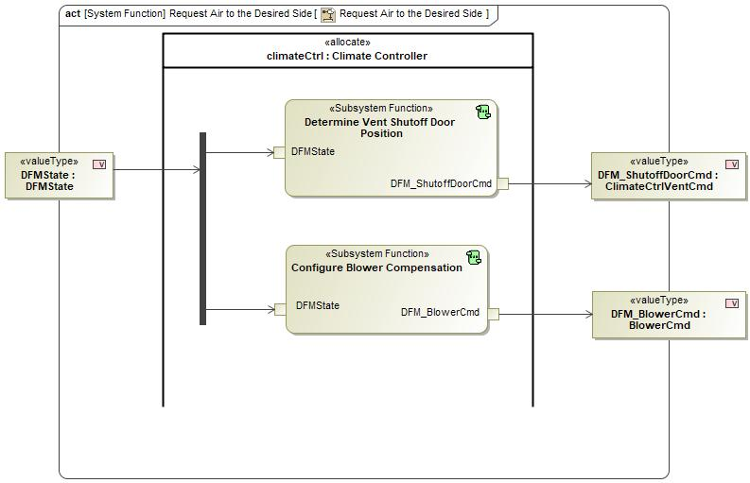

Figure 2: Activity Diagram of -1585998372.jpg “Request Air to the Desired Side” calling 1693216511.jpg “Configure Blower Compensation”

### Function Interfaces

#### Logical Inputs

|  |  |
| --- | --- |
| **Signal Name** | **Description** |
| DFMState  Type:  -1346609435.jpg DFMState | Signal Description:  Logical signal of DFM ON/OFF state; On--request air to only the driver; Off--request air to both driver and passenger  Received from:   * -927225563.jpg Activity Parameter Node: DFMState |

#### Logical Outputs

|  |  |
| --- | --- |
| **Signal Name** | **Description** |
| DFM_BlowerCmd  Type:  -17019447.jpg BlowerCmd | Signal Description:  Logical signal of the command DFM sends to the blower control for air flow adjustment  Sent to:   * -927225563.jpg Activity Parameter Node: DFM_BlowerCmd |

#### Logical Parameters

*Not supported by MagicDraw report generation.*

### Function Modeling

#### Use Cases

*Not supported by MagicDraw report generation.*

#### State Charts / Activity Diagrams / Sequence Diagrams / Decision Tables

No diagrams internal to function specified.

### Function Requirements

#### Functional Requirements

##### Normal Operation

Adjust - Blower Compensation

"Configure Blower Compensation" SubSystem Function shall calculate the output "DFM_BlowerCmd" to adjust the blower speed to balance airflow across the open registers, based on the value of the input "DFMState".

|  |  |  |  |  |  |  |  |
| --- | --- | --- | --- | --- | --- | --- | --- |
| Requirement ID: | | | | | | | |
| **Rationale** |  | | | | | | |
| **Acceptance Criteria** |  | | | | | | |
| **Notes** |  | | | | | | |
| **Source** |  | | | | | **Owner** |  |
| **Source Req.** | * -1191876235.jpg DFM - Airflow | | | | | **V&V Method** |  |
| **Type** |  | | | **Priority** |  | **Status** |  |
| [Req. Template](http://wiki.ford.com/display/RequirementsEngineering/Requirements+Attributes) Version | | 6.0 | End of Requirement | | | | |

Adjust - Blower Compensation Transition Rate

When "Configure Blower Compensation" SubSystem Function shall calculate the blower speed such that the transition is over the period of time less than MaxTransitionTime.

**This is also in Feature Requirement**Response Time (Alan: 3~4s)**

|  |  |  |  |  |  |  |  |
| --- | --- | --- | --- | --- | --- | --- | --- |
| Requirement ID: | | | | | | | |
| **Rationale** |  | | | | | | |
| **Acceptance Criteria** |  | | | | | | |
| **Notes** |  | | | | | | |
| **Source** |  | | | | | **Owner** |  |
| **Source Req.** | * -1191876235.jpg DFM - Airflow | | | | | **V&V Method** |  |
| **Type** |  | | | **Priority** |  | **Status** |  |
| [Req. Template](http://wiki.ford.com/display/RequirementsEngineering/Requirements+Attributes) Version | | 6.0 | End of Requirement | | | | |

##### Error Handling

No Error Handling Requirements specified.

#### Non-Functional Requirements

No Non-Functional Requirements specified.

#### Functional Safety Requirements

No Functional Safety Requirements specified.

##### ASIL Decomposition of Functional Safety Requirements

No Functional Safety Requirements with ASIL Decompositions specified.

#### Other Requirements

##### Design Requirements

No Design Requirements specified.

## -1585998372.jpg Decide DFM Operation Mode

### Function Overview

#### Description

Function is allocated to:

* -443588119.jpg Climate System <<Logical>>
* -443588119.jpg DFM Feature <<Logical>>
* -443588119.jpg HMI System <<Logical>>
* -443588119.jpg Restraint System <<Logical>>
* -443588119.jpg Users <<Logical>>
* -443588119.jpg Vehicle Status System <<Logical>>
* -443588119.jpg Vehicle System <<Logical>>

Function "Decide DFM Operation Mode" shall set the output "DFMStateTarget" to "On" or "Off" based on the input values of: ambient temperature "AmbTemp", vehicle ignition status "VehStatus", user inputs "UserInputs", FrntPsngr seat occupancy "FrntPsngrStatus" and climate system status "ClimateCtrlStatus". The output "DFMStateTarget" is sent to downstream functions "Adjust Air to the Desired Side" and "Output DFM Feedback".

#### Variants

*Not supported by MagicDraw report generation.*

#### Input Requirements

*Not supported by MagicDraw report generation.*

#### Assumptions

No assumptions specified for this function.

#### References

##### Ford Documents

List here all Ford internal documents, which are directly related to the feature.

| **Reference** | **Title** | **Doc. ID** | **Revision** |
| --- | --- | --- | --- |
|  |  |  |  |

Table 5: Ford internal Documents *(not specified in model)*

##### External Documents and Publications

The list of external documents could include books, reports and online sources.

| **Reference** | **Document / Publication** |
| --- | --- |
|  |  |

Table 7: External documents and publications *(not specified in model)*

#### Glossary

See Appendix for Definitions and Abbreviations.

### Function Scope

The -1585998372.jpg **– “Decide DFM Operation Mode”** function is called by the following functions:

* -1304866114.jpg – “Decide DFM Operation Mode”
* 34249308.jpg – “Request Airflow to the Desired Side”

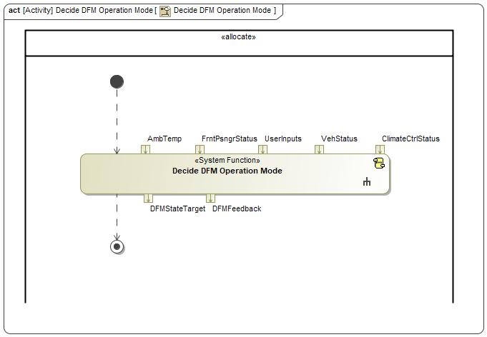

Figure 2: Activity Diagram of -1304866114.jpg “Decide DFM Operation Mode” calling -1585998372.jpg “Decide DFM Operation Mode”

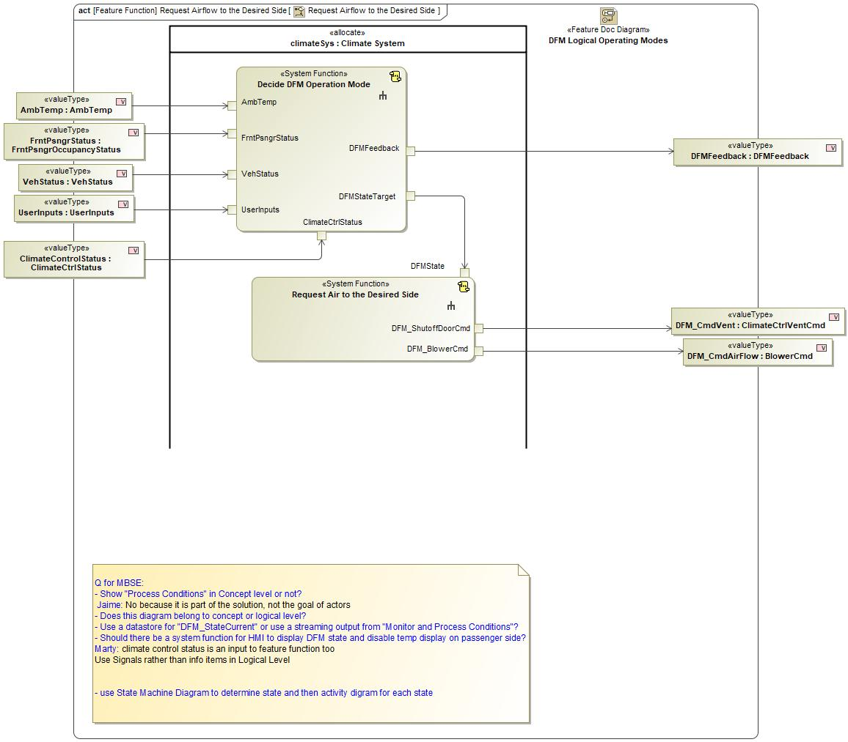

Figure 2: Activity Diagram of 34249308.jpg “Request Airflow to the Desired Side” calling -1585998372.jpg “Decide DFM Operation Mode”

### Function Interfaces

#### Logical Inputs

|  |  |
| --- | --- |
| **Signal Name** | **Description** |
| AmbTemp  Type:  -17019447.jpg AmbTemp | Signal Description:  Logical signal of environment temperature (in °F) as input for DFM to determine whether or not to activate  Received from:   * -927225563.jpg Activity Parameter Node: AmbTemp |
| ClimateCtrlStatus  Type:  -17019447.jpg ClimateCtrlStatus | Signal Description:  Logical signal DFM receives from the climate system about purge and defrost event status  Received from:   * -927225563.jpg Activity Parameter Node: ClimateControlStatus |
| FrntPsngrStatus  Type:  -17019447.jpg FrntPsngrOccupancyStatus | Received from:   * -927225563.jpg Activity Parameter Node: OccupancyStat |
| UserInputs  Type:  -17019447.jpg UserInputs | Received from:   * -927225563.jpg Activity Parameter Node: UserInputs |
| VehStatus  Type:  -17019447.jpg VehStatus | Received from:   * -927225563.jpg Activity Parameter Node: VehStatus |

#### Logical Outputs

|  |  |
| --- | --- |
| **Signal Name** | **Description** |
| DFMStateTarget  Type:  -1346609435.jpg DFMState | Signal Description:  Logical signal of DFM ON/OFF state; On--request air to only the driver; Off--request air to both driver and passenger  Sent to:   * -1585998372.jpg Request Air to the Desired Side |
| DFMFeedback  Type:  -17019447.jpg DFMFeedback | Signal Description:  Logical signal of the command DFM sends HMI system to notify users about DFM status  Sent to:   * -927225563.jpg Activity Parameter Node: DFMFeedback |

#### Logical Parameters

*Not supported by MagicDraw report generation.*

### Function Modeling

#### Use Cases

*Not supported by MagicDraw report generation.*

#### State Charts / Activity Diagrams / Sequence Diagrams / Decision Tables



Figure 3: Decide DFM Operation Mode

### Function Requirements

#### Functional Requirements

##### Normal Operation

DFM - HMI Display

"Decide DFM Operation Mode" system function shall output "DFMFeedback" based on input values received though “AmbTemp”, “VehStatus”,”ClimateCtrlStatus”, “FrntPsngrOccupancyStatus” and “userInputs".

|  |  |  |  |  |  |  |  |
| --- | --- | --- | --- | --- | --- | --- | --- |
| Requirement ID: | | | | | | | |
| **Rationale** |  | | | | | | |
| **Acceptance Criteria** |  | | | | | | |
| **Notes** | 01262021: Only sub system function can be allocated to component (controller/sensor/act) at the implementation level. A system function without subsystem function breakdowns can cause issues later. Suggest turning "Output DFM Feedback" as a sub-sys function, and include it in another system function. Change this system req to be more abstract, and create detailed derived req. | | | | | | |
| **Source** |  | | | | | **Owner** |  |
| **Source Req.** | * 343713261.jpg HMI Display of DFM State | | | | | **V&V Method** |  |
| **Type** |  | | | **Priority** | 1 - High | **Status** |  |
| [Req. Template](http://wiki.ford.com/display/RequirementsEngineering/Requirements+Attributes) Version | | 6.0 | End of Requirement | | | | |

Restraint - FrntPsngr

Restraint system shall provide the front passenger seat occupancy sensor measurement to the Climate System.

|  |  |  |  |  |  |  |  |
| --- | --- | --- | --- | --- | --- | --- | --- |
| Requirement ID: | | | | | | | |
| **Rationale** |  | | | | | | |
| **Acceptance Criteria** |  | | | | | | |
| **Notes** |  | | | | | | |
| **Source** |  | | | | | **Owner** |  |
| **Source Req.** | * 343713261.jpg Passenger NOT Detected | | | | | **V&V Method** |  |
| **Type** |  | | | **Priority** | 1 - High | **Status** |  |
| [Req. Template](http://wiki.ford.com/display/RequirementsEngineering/Requirements+Attributes) Version | | 6.0 | End of Requirement | | | | |

Vehicle Status

Vehicle Status Provider shall provide ambient temperature and vehicle ignition status to DFM.

|  |  |  |  |  |  |  |  |
| --- | --- | --- | --- | --- | --- | --- | --- |
| Requirement ID: | | | | | | | |
| **Rationale** |  | | | | | | |
| **Acceptance Criteria** |  | | | | | | |
| **Notes** |  | | | | | | |
| **Source** |  | | | | | **Owner** |  |
| **Source Req.** | * 343713261.jpg Vehicle Enabling Conditions | | | | | **V&V Method** |  |
| **Type** |  | | | **Priority** | 1 - High | **Status** |  |
| [Req. Template](http://wiki.ford.com/display/RequirementsEngineering/Requirements+Attributes) Version | | 6.0 | End of Requirement | | | | |

HMI - User Input

HMI system shall allow users to select:

1) "On", "Off" or "NoSelection" for DFM;

2) "On" or "Off" for Dual Mode;

3) change in the front passenger temperature setpoint

|  |  |  |  |  |  |  |  |
| --- | --- | --- | --- | --- | --- | --- | --- |
| Requirement ID: | | | | | | | |
| **Rationale** |  | | | | | | |
| **Acceptance Criteria** |  | | | | | | |
| **Notes** |  | | | | | | |
| **Source** |  | | | | | **Owner** |  |
| **Source Req.** | * 343713261.jpg HMI DFM Switch | | | | | **V&V Method** |  |
| **Type** |  | | | **Priority** | 1 - High | **Status** |  |
| [Req. Template](http://wiki.ford.com/display/RequirementsEngineering/Requirements+Attributes) Version | | 6.0 | End of Requirement | | | | |

DFM - Mode

"Decide DFM Operation Mode” system function shall set “DFMState” output to “On” or “Off”, based on input values received though “AmbTemp”, “VehStatus”,”ClimateCtrlStatus”, “FrntPsngrOccupancyStatus” and “userInputs".

|  |  |  |  |  |  |  |  |
| --- | --- | --- | --- | --- | --- | --- | --- |
| Requirement ID: | | | | | | | |
| **Rationale** |  | | | | | | |
| **Acceptance Criteria** |  | | | | | | |
| **Notes** | 01262021: remove feature function in satisfied by - the relationship is incorrect; logical structure may not be needed TBD ask Jaime to confirm; req owner is FO usually for functional requirements; test engineer if it is a test requirement | | | | | | |
| **Source** |  | | | | | **Owner** |  |
| **Source Req.** | * 343713261.jpg Inhibitors * 343713261.jpg Passenger NOT Detected * 343713261.jpg Vehicle Enabling Conditions * 343713261.jpg User Input Received * 343713261.jpg Error Handling | | | | | **V&V Method** |  |
| **Type** |  | | | **Priority** | 1 - High | **Status** |  |
| [Req. Template](http://wiki.ford.com/display/RequirementsEngineering/Requirements+Attributes) Version | | 6.0 | End of Requirement | | | | |

##### Error Handling

No Error Handling Requirements specified.

#### Non-Functional Requirements

No Non-Functional Requirements specified.

#### Functional Safety Requirements

No Functional Safety Requirements specified.

##### ASIL Decomposition of Functional Safety Requirements

No Functional Safety Requirements with ASIL Decompositions specified.

#### Other Requirements

##### Design Requirements

No Design Requirements specified.

## 1693216511.jpg Determine Inhibitors

### Function Overview

#### Description

Function is allocated to:

* 1010756237.jpg Climate Controller <<Logical>>

Subsystem Function "Determine Inhibitors" shall set the output "DFMInhibit" to "On" or "Off", based on the input values of "DFMVehCheck" and "DFMClimateCheck".

#### Variants

*Not supported by MagicDraw report generation.*

#### Input Requirements

*Not supported by MagicDraw report generation.*

#### Assumptions

No assumptions specified for this function.

#### References

##### Ford Documents

List here all Ford internal documents, which are directly related to the feature.

| **Reference** | **Title** | **Doc. ID** | **Revision** |
| --- | --- | --- | --- |
|  |  |  |  |

Table 5: Ford internal Documents *(not specified in model)*

##### External Documents and Publications

The list of external documents could include books, reports and online sources.

| **Reference** | **Document / Publication** |
| --- | --- |
|  |  |

Table 7: External documents and publications *(not specified in model)*

#### Glossary

See Appendix for Definitions and Abbreviations.

### Function Scope

The 1693216511.jpg **– “Determine Inhibitors”** function is called by the following functions:

* -1585998372.jpg – “Decide DFM Operation Mode”



Figure 2: Activity Diagram of -1585998372.jpg “Decide DFM Operation Mode” calling 1693216511.jpg “Determine Inhibitors”

### Function Interfaces

#### Logical Inputs

|  |  |
| --- | --- |
| **Signal Name** | **Description** |
| DFMVehCheck  Type:  -17019447.jpg DFMVehCheck | Signal Description:  Logical signal indicating whether vehicle level system check is passed for DFM to become On  Received from:   * 1693216511.jpg Process Vehicle Enabling Conditions |
| DFMClimateCheck  Type:  -17019447.jpg DFMClimateCheck | Signal Description:  Logical signal indicating whether climate system check is passed for DFM to become On  Received from:   * 1693216511.jpg Process Climate System Inhibitors |

#### Logical Outputs

|  |  |
| --- | --- |
| **Signal Name** | **Description** |
| DFMInhibit  Type:  -1346609435.jpg DFMInhibit | Signal Description:  Logical signal indicating whether DFM is inhibited  Sent to:   * 1693216511.jpg Arbitrate Mode |

#### Logical Parameters

*Not supported by MagicDraw report generation.*

### Function Modeling

#### Use Cases

*Not supported by MagicDraw report generation.*

#### State Charts / Activity Diagrams / Sequence Diagrams / Decision Tables

No diagrams internal to function specified.

### Function Requirements

#### Functional Requirements

##### Normal Operation

Mode - Determine - Not Inhibited

"Determine Inhibitors" SubSystem Function shall output "DFMInhibit = NotInhibited" when the input values are:

1) "DFMVehCheck = Pass";

and 2) "DFMClimateCheck = Pass".

|  |  |  |  |  |  |  |  |
| --- | --- | --- | --- | --- | --- | --- | --- |
| Requirement ID: | | | | | | | |
| **Rationale** |  | | | | | | |
| **Acceptance Criteria** |  | | | | | | |
| **Notes** |  | | | | | | |
| **Source** |  | | | | | **Owner** |  |
| **Source Req.** | * 1788774874.jpg DFM - Mode | | | | | **V&V Method** |  |
| **Type** |  | | | **Priority** |  | **Status** |  |
| [Req. Template](http://wiki.ford.com/display/RequirementsEngineering/Requirements+Attributes) Version | | 6.0 | End of Requirement | | | | |

Mode - Determine - Inhibited

"Determine Inhibitors" SubSystem Function shall output "DFMInhibit = Inhibited" when the input values are:

1) "DFMVehCheck = Fail";

or 2) "DFMClimateCheck = Fail".

|  |  |  |  |  |  |  |  |
| --- | --- | --- | --- | --- | --- | --- | --- |
| Requirement ID: | | | | | | | |
| **Rationale** |  | | | | | | |
| **Acceptance Criteria** |  | | | | | | |
| **Notes** |  | | | | | | |
| **Source** |  | | | | | **Owner** |  |
| **Source Req.** | * 1788774874.jpg DFM - Mode | | | | | **V&V Method** |  |
| **Type** |  | | | **Priority** |  | **Status** |  |
| [Req. Template](http://wiki.ford.com/display/RequirementsEngineering/Requirements+Attributes) Version | | 6.0 | End of Requirement | | | | |

##### Error Handling

No Error Handling Requirements specified.

#### Non-Functional Requirements

No Non-Functional Requirements specified.

#### Functional Safety Requirements

No Functional Safety Requirements specified.

##### ASIL Decomposition of Functional Safety Requirements

No Functional Safety Requirements with ASIL Decompositions specified.

#### Other Requirements

##### Design Requirements

No Design Requirements specified.

## 1693216511.jpg Determine Request

### Function Overview

#### Description

Function is allocated to:

* 1010756237.jpg Climate Controller <<Logical>>

Subsystem Function "Determine Request" shall set the output "DFMRequest" to "On" or "Off", based on the input values of "DFMReqManual" and "DFMReqAuto".

#### Variants

*Not supported by MagicDraw report generation.*

#### Input Requirements

*Not supported by MagicDraw report generation.*

#### Assumptions

No assumptions specified for this function.

#### References

##### Ford Documents

List here all Ford internal documents, which are directly related to the feature.

| **Reference** | **Title** | **Doc. ID** | **Revision** |
| --- | --- | --- | --- |
|  |  |  |  |

Table 5: Ford internal Documents *(not specified in model)*

##### External Documents and Publications

The list of external documents could include books, reports and online sources.

| **Reference** | **Document / Publication** |
| --- | --- |
|  |  |

Table 7: External documents and publications *(not specified in model)*

#### Glossary

See Appendix for Definitions and Abbreviations.

### Function Scope

The 1693216511.jpg **– “Determine Request”** function is called by the following functions:

* -1585998372.jpg – “Decide DFM Operation Mode”



Figure 2: Activity Diagram of -1585998372.jpg “Decide DFM Operation Mode” calling 1693216511.jpg “Determine Request”

### Function Interfaces

#### Logical Inputs

|  |  |
| --- | --- |
| **Signal Name** | **Description** |
| DFMReqAuto  Type:  -17019447.jpg DFMReqAuto | Signal Description:  Logical signal indicating DFM is requested by automatic system logic  Received from:   * 1693216511.jpg Process Automatic Strategy |
| DFMReqManual  Type:  -17019447.jpg DFMReqManual | Signal Description:  Logical signal indicating DFM is requested by user manual inputs through HMI  Received from:   * 1693216511.jpg Process Manual Request |

#### Logical Outputs

|  |  |
| --- | --- |
| **Signal Name** | **Description** |
| DFMRequest  Type:  -1346609435.jpg DFMRequest | Signal Description:  Logical signal indicating DFM is requested to be On/Off regardless of method  Sent to:   * 1693216511.jpg Arbitrate Mode |

#### Logical Parameters

*Not supported by MagicDraw report generation.*

### Function Modeling

#### Use Cases

*Not supported by MagicDraw report generation.*

#### State Charts / Activity Diagrams / Sequence Diagrams / Decision Tables

No diagrams internal to function specified.

### Function Requirements

#### Functional Requirements

##### Normal Operation

Mode - Determine - Request Off

"Determine Request" SubSystem Function shall output "DFMRequest = Off" when the input values are:

1) "DFMReqManual = Off";

or 2) "DFMReqManual = NoSelection" AND "DFMReqAuto = Off".

|  |  |  |  |  |  |  |  |
| --- | --- | --- | --- | --- | --- | --- | --- |
| Requirement ID: | | | | | | | |
| **Rationale** |  | | | | | | |
| **Acceptance Criteria** |  | | | | | | |
| **Notes** |  | | | | | | |
| **Source** |  | | | | | **Owner** |  |
| **Source Req.** | * 1788774874.jpg DFM - Mode | | | | | **V&V Method** |  |
| **Type** |  | | | **Priority** |  | **Status** |  |
| [Req. Template](http://wiki.ford.com/display/RequirementsEngineering/Requirements+Attributes) Version | | 6.0 | End of Requirement | | | | |

Mode - Determine - Request On

"Determine Request" SubSystem Function shall output "DFMRequest = On" when the input values are:

1) "DFMReqManual = On";

or 2) "DFMReqManual = NoSelection" AND "DFMReqAuto = On".

|  |  |  |  |  |  |  |  |
| --- | --- | --- | --- | --- | --- | --- | --- |
| Requirement ID: | | | | | | | |
| **Rationale** |  | | | | | | |
| **Acceptance Criteria** |  | | | | | | |
| **Notes** |  | | | | | | |
| **Source** |  | | | | | **Owner** |  |
| **Source Req.** | * 1788774874.jpg DFM - Mode | | | | | **V&V Method** |  |
| **Type** |  | | | **Priority** |  | **Status** |  |
| [Req. Template](http://wiki.ford.com/display/RequirementsEngineering/Requirements+Attributes) Version | | 6.0 | End of Requirement | | | | |

##### Error Handling

No Error Handling Requirements specified.

#### Non-Functional Requirements

No Non-Functional Requirements specified.

#### Functional Safety Requirements

No Functional Safety Requirements specified.

##### ASIL Decomposition of Functional Safety Requirements

No Functional Safety Requirements with ASIL Decompositions specified.

#### Other Requirements

##### Design Requirements

No Design Requirements specified.

## 1693216511.jpg Determine Vent Shutoff Door Position

### Function Overview

#### Description

Function is allocated to:

* 1010756237.jpg Climate Controller <<Logical>>
* -443588119.jpg Psngr Outboard Floor Vent <<Logical>>
* -443588119.jpg Psngr Outboard Panel Vent <<Logical>>
* -443588119.jpg Psngr Outboard Vents Controller <<Logical>>

Subsystem Function "Adjust Vent Shutoff Door Position" shall determine the shutoff door Open/Closed command "DFM_ShutoffDoorCmd" based on the input "DFMState".

#### Variants

*Not supported by MagicDraw report generation.*

#### Input Requirements

*Not supported by MagicDraw report generation.*

#### Assumptions

No assumptions specified for this function.

#### References

##### Ford Documents

List here all Ford internal documents, which are directly related to the feature.

| **Reference** | **Title** | **Doc. ID** | **Revision** |
| --- | --- | --- | --- |
|  |  |  |  |

Table 5: Ford internal Documents *(not specified in model)*

##### External Documents and Publications

The list of external documents could include books, reports and online sources.

| **Reference** | **Document / Publication** |
| --- | --- |
|  |  |

Table 7: External documents and publications *(not specified in model)*

#### Glossary

See Appendix for Definitions and Abbreviations.

### Function Scope

The 1693216511.jpg **– “Determine Vent Shutoff Door Position”** function is called by the following functions:

* -1585998372.jpg – “Request Air to the Desired Side”



Figure 2: Activity Diagram of -1585998372.jpg “Request Air to the Desired Side” calling 1693216511.jpg “Determine Vent Shutoff Door Position”

### Function Interfaces

#### Logical Inputs

|  |  |
| --- | --- |
| **Signal Name** | **Description** |
| DFMState  Type:  -1346609435.jpg DFMState | Signal Description:  Logical signal of DFM ON/OFF state; On--request air to only the driver; Off--request air to both driver and passenger  Received from:   * -927225563.jpg Activity Parameter Node: DFMState |

#### Logical Outputs

|  |  |
| --- | --- |
| **Signal Name** | **Description** |
| DFM_ShutoffDoorCmd  Type:  -17019447.jpg ClimateCtrlVentCmd | Signal Description:  Logical signal of the command DFM sends to the vent control for air flow adjustment both at the floor and on the instrument panel  Sent to:   * -927225563.jpg Activity Parameter Node: DFM_ShutoffDoorCmd |

#### Logical Parameters

*Not supported by MagicDraw report generation.*

### Function Modeling

#### Use Cases

*Not supported by MagicDraw report generation.*

#### State Charts / Activity Diagrams / Sequence Diagrams / Decision Tables

No diagrams internal to function specified.

### Function Requirements

#### Functional Requirements

##### Normal Operation

Adjust - Vent Shutoff Door

"Determine Vent Shutoff Door Position" SubSystem Function shall set the output "DFM_ShutoffDoorCmd" to "FullyOpen" if the input is "DFMState = Off"; or to "Fully Closed" if the input is "DFMState = On".

|  |  |  |  |  |  |  |  |
| --- | --- | --- | --- | --- | --- | --- | --- |
| Requirement ID: | | | | | | | |
| **Rationale** | Provide user DFM activation automatically | | | | | | |
| **Acceptance Criteria** | Observe that HMI displays DFM state is active | | | | | | |
| **Notes** |  | | | | | | |
| **Source** |  | | | | | **Owner** |  |
| **Source Req.** | * -1191876235.jpg DFM - Airflow | | | | | **V&V Method** |  |
| **Type** |  | | | **Priority** |  | **Status** |  |
| [Req. Template](http://wiki.ford.com/display/RequirementsEngineering/Requirements+Attributes) Version | | 6.0 | End of Requirement | | | | |

##### Error Handling

No Error Handling Requirements specified.

#### Non-Functional Requirements

No Non-Functional Requirements specified.

#### Functional Safety Requirements

No Functional Safety Requirements specified.

##### ASIL Decomposition of Functional Safety Requirements

No Functional Safety Requirements with ASIL Decompositions specified.

#### Other Requirements

##### Design Requirements

No Design Requirements specified.

## 1693216511.jpg Output DFM Feedback

### Function Overview

#### Description

Function is allocated to:

* 1010756237.jpg Climate Controller <<Logical>>
* -443588119.jpg Climate System <<Logical>>
* -443588119.jpg DFM Feature <<Logical>>
* -443588119.jpg HMI System <<Logical>>
* -443588119.jpg Users <<Logical>>
* -443588119.jpg Vehicle System <<Logical>>

Function "Output DFM Feedback" shall output HMI feedback "DFMFeedback" to user after "Adjust Air to the Desired Side" function has completed based on the input value "DFMState".

#### Variants

*Not supported by MagicDraw report generation.*

#### Input Requirements

*Not supported by MagicDraw report generation.*

#### Assumptions

No assumptions specified for this function.

#### References

##### Ford Documents

List here all Ford internal documents, which are directly related to the feature.

| **Reference** | **Title** | **Doc. ID** | **Revision** |
| --- | --- | --- | --- |
|  |  |  |  |

Table 5: Ford internal Documents *(not specified in model)*

##### External Documents and Publications

The list of external documents could include books, reports and online sources.

| **Reference** | **Document / Publication** |
| --- | --- |
|  |  |

Table 7: External documents and publications *(not specified in model)*

#### Glossary

See Appendix for Definitions and Abbreviations.

### Function Scope

The 1693216511.jpg **– “Output DFM Feedback”** function is called by the following functions:

* -1585998372.jpg – “Decide DFM Operation Mode”



Figure 2: Activity Diagram of -1585998372.jpg “Decide DFM Operation Mode” calling 1693216511.jpg “Output DFM Feedback”

### Function Interfaces

#### Logical Inputs

|  |  |
| --- | --- |
| **Signal Name** | **Description** |
| DFMState  Type:  -1346609435.jpg DFMState | Signal Description:  Logical signal of DFM ON/OFF state; On--request air to only the driver; Off--request air to both driver and passenger  Received from:   * 1693216511.jpg Arbitrate Mode |

#### Logical Outputs

|  |  |
| --- | --- |
| **Signal Name** | **Description** |
| DFMFeedback  Type:  -17019447.jpg DFMFeedback | Signal Description:  Logical signal of the command DFM sends HMI system to notify users about DFM status  Sent to:   * -927225563.jpg Activity Parameter Node: DFMFeedback |

#### Logical Parameters

*Not supported by MagicDraw report generation.*

### Function Modeling

#### Use Cases

*Not supported by MagicDraw report generation.*

#### State Charts / Activity Diagrams / Sequence Diagrams / Decision Tables

No diagrams internal to function specified.

### Function Requirements

#### Functional Requirements

##### Normal Operation

Display - DFM Off

Ouput DFM Feedback" subsystem function shall set "DFMFeedback" output to "dfmStateDisplay=Off" and "frntPsngrTempDisplay=On" when the input "DFMState" is "Off".

|  |  |  |  |  |  |  |  |
| --- | --- | --- | --- | --- | --- | --- | --- |
| Requirement ID: | | | | | | | |
| **Rationale** |  | | | | | | |
| **Acceptance Criteria** |  | | | | | | |
| **Notes** |  | | | | | | |
| **Source** |  | | | | | **Owner** |  |
| **Source Req.** | * -1191876235.jpg DFM - HMI Display | | | | | **V&V Method** |  |
| **Type** |  | | | **Priority** |  | **Status** |  |
| [Req. Template](http://wiki.ford.com/display/RequirementsEngineering/Requirements+Attributes) Version | | 6.0 | End of Requirement | | | | |

Display - DFM On

"Ouput DFM Feedback" subsystem function shall set "DFMFeedback" output to "dfmStateDisplay=On" and "frntPsngrTempDisplay=Off" when the input "DFMState" is "On".

|  |  |  |  |  |  |  |  |
| --- | --- | --- | --- | --- | --- | --- | --- |
| Requirement ID: | | | | | | | |
| **Rationale** |  | | | | | | |
| **Acceptance Criteria** |  | | | | | | |
| **Notes** |  | | | | | | |
| **Source** |  | | | | | **Owner** |  |
| **Source Req.** | * -1191876235.jpg DFM - HMI Display | | | | | **V&V Method** |  |
| **Type** |  | | | **Priority** |  | **Status** |  |
| [Req. Template](http://wiki.ford.com/display/RequirementsEngineering/Requirements+Attributes) Version | | 6.0 | End of Requirement | | | | |

##### Error Handling

No Error Handling Requirements specified.

#### Non-Functional Requirements

No Non-Functional Requirements specified.

#### Functional Safety Requirements

No Functional Safety Requirements specified.

##### ASIL Decomposition of Functional Safety Requirements

No Functional Safety Requirements with ASIL Decompositions specified.

#### Other Requirements

##### Design Requirements

No Design Requirements specified.

## 1693216511.jpg Process Automatic Strategy

### Function Overview

#### Description

Function is allocated to:

* 1010756237.jpg Climate Controller <<Logical>>
* -443588119.jpg Seat Occupency Sensor <<Logical>>

Subsystem Function "Process Automatic Strategy" shall set the output "DFMReqAuto" to "On" or "Off", based on the input front passenger seat occupancy "FrntPsngrStatus" from the restraint control system.

#### Variants

*Not supported by MagicDraw report generation.*

#### Input Requirements

*Not supported by MagicDraw report generation.*

#### Assumptions

No assumptions specified for this function.

#### References

##### Ford Documents

List here all Ford internal documents, which are directly related to the feature.

| **Reference** | **Title** | **Doc. ID** | **Revision** |
| --- | --- | --- | --- |
|  |  |  |  |

Table 5: Ford internal Documents *(not specified in model)*

##### External Documents and Publications

The list of external documents could include books, reports and online sources.

| **Reference** | **Document / Publication** |
| --- | --- |
|  |  |

Table 7: External documents and publications *(not specified in model)*

#### Glossary

See Appendix for Definitions and Abbreviations.

### Function Scope

The 1693216511.jpg **– “Process Automatic Strategy”** function is called by the following functions:

* -1585998372.jpg – “Decide DFM Operation Mode”
* -1304866114.jpg – “Process Automatic Strategy”



Figure 2: Activity Diagram of -1585998372.jpg “Decide DFM Operation Mode” calling 1693216511.jpg “Process Automatic Strategy”

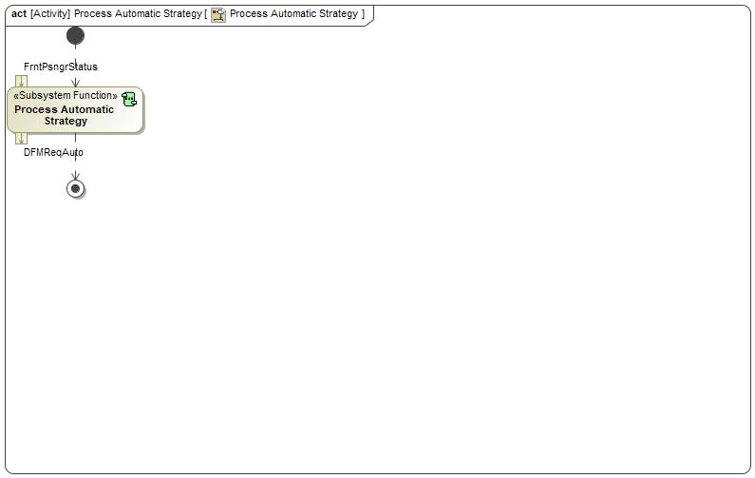

Figure 2: Activity Diagram of -1304866114.jpg “Process Automatic Strategy” calling 1693216511.jpg “Process Automatic Strategy”

### Function Interfaces

#### Logical Inputs

|  |  |
| --- | --- |
| **Signal Name** | **Description** |
| FrntPsngrStatus  Type:  -17019447.jpg FrntPsngrOccupancyStatus | Received from:   * -927225563.jpg Activity Parameter Node: FrntPsngrStatus |

#### Logical Outputs

|  |  |
| --- | --- |
| **Signal Name** | **Description** |
| DFMReqAuto  Type:  -17019447.jpg DFMReqAuto | Signal Description:  Logical signal indicating DFM is requested by automatic system logic  Sent to:   * 1693216511.jpg Determine Request |

#### Logical Parameters

*Not supported by MagicDraw report generation.*

### Function Modeling

#### Use Cases

*Not supported by MagicDraw report generation.*

#### State Charts / Activity Diagrams / Sequence Diagrams / Decision Tables

No diagrams internal to function specified.

### Function Requirements

#### Functional Requirements

##### Normal Operation

Mode - Auto Off

"Process Automatic Strategy" SubSystem Function shall output "DFMReqAuto = Off" when the input "FrntPsngrStatus" takes the value "Detected".

|  |  |  |  |  |  |  |  |
| --- | --- | --- | --- | --- | --- | --- | --- |
| Requirement ID: | | | | | | | |
| **Rationale** |  | | | | | | |
| **Acceptance Criteria** |  | | | | | | |
| **Notes** |  | | | | | | |
| **Source** |  | | | | | **Owner** |  |
| **Source Req.** | * 1788774874.jpg DFM - Mode | | | | | **V&V Method** |  |
| **Type** |  | | | **Priority** |  | **Status** |  |
| [Req. Template](http://wiki.ford.com/display/RequirementsEngineering/Requirements+Attributes) Version | | 6.0 | End of Requirement | | | | |

Mode - Auto On

"Process Automatic Strategy" SubSystem Function shall output "DFMReqAuto = On" when the input value is "FrntPsngrStatus = NotDetected".

|  |  |  |  |  |  |  |  |
| --- | --- | --- | --- | --- | --- | --- | --- |
| Requirement ID: | | | | | | | |
| **Rationale** |  | | | | | | |
| **Acceptance Criteria** |  | | | | | | |
| **Notes** |  | | | | | | |
| **Source** |  | | | | | **Owner** |  |
| **Source Req.** | * 1788774874.jpg DFM - Mode | | | | | **V&V Method** |  |
| **Type** |  | | | **Priority** |  | **Status** |  |
| [Req. Template](http://wiki.ford.com/display/RequirementsEngineering/Requirements+Attributes) Version | | 6.0 | End of Requirement | | | | |

##### Error Handling

Mode - Auto Off - Error Handling

"Process Automatic Strategy" SubSystem Function shall output "DFMReqAuto = Off" when the input "FrntPsngrStatus" takes the value "SignalNotAvailable"

|  |  |  |  |  |  |  |  |
| --- | --- | --- | --- | --- | --- | --- | --- |
| Requirement ID: | | | | | | | |
| **Rationale** |  | | | | | | |
| **Acceptance Criteria** |  | | | | | | |
| **Notes** |  | | | | | | |
| **Source** |  | | | | | **Owner** |  |
| **Source Req.** | * 1788774874.jpg DFM - Mode | | | | | **V&V Method** |  |
| **Type** |  | | | **Priority** |  | **Status** |  |
| [Req. Template](http://wiki.ford.com/display/RequirementsEngineering/Requirements+Attributes) Version | | 6.0 | End of Requirement | | | | |

#### Non-Functional Requirements

No Non-Functional Requirements specified.

#### Functional Safety Requirements

No Functional Safety Requirements specified.

##### ASIL Decomposition of Functional Safety Requirements

No Functional Safety Requirements with ASIL Decompositions specified.

#### Other Requirements

##### Design Requirements

No Design Requirements specified.

## 1693216511.jpg Process Climate System Inhibitors

### Function Overview

#### Description

Function is allocated to:

* 1010756237.jpg Climate Controller <<Logical>>

Subsystem Function "Process Climate System Inhibitors" shall set the output "DFMClimateCheck" to "Pass" or "Fail" indicating the pass or fail of the climate system inhibitor check, based on the input value of "ClimateStatus".

#### Variants

*Not supported by MagicDraw report generation.*

#### Input Requirements

*Not supported by MagicDraw report generation.*

#### Assumptions

No assumptions specified for this function.

#### References

##### Ford Documents

List here all Ford internal documents, which are directly related to the feature.

| **Reference** | **Title** | **Doc. ID** | **Revision** |
| --- | --- | --- | --- |
|  |  |  |  |

Table 5: Ford internal Documents *(not specified in model)*

##### External Documents and Publications

The list of external documents could include books, reports and online sources.

| **Reference** | **Document / Publication** |
| --- | --- |
|  |  |

Table 7: External documents and publications *(not specified in model)*

#### Glossary

See Appendix for Definitions and Abbreviations.

### Function Scope

The 1693216511.jpg **– “Process Climate System Inhibitors”** function is called by the following functions:

* -1585998372.jpg – “Decide DFM Operation Mode”
* -1304866114.jpg – “Process Climate System Inhibitors”



Figure 2: Activity Diagram of -1585998372.jpg “Decide DFM Operation Mode” calling 1693216511.jpg “Process Climate System Inhibitors”

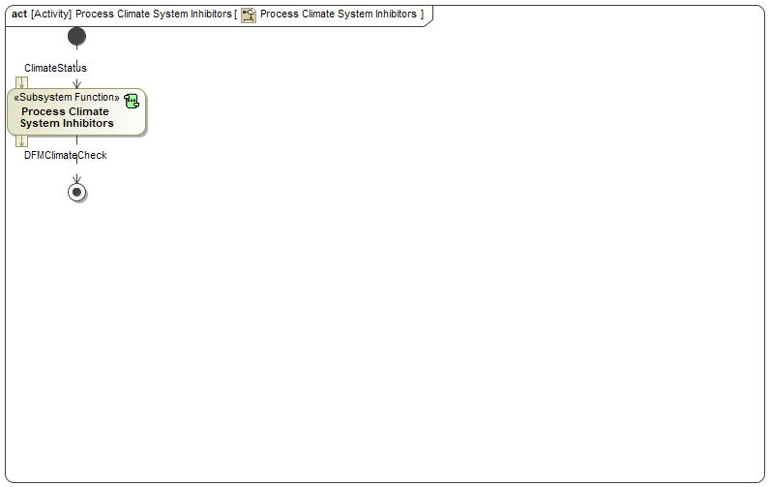

Figure 2: Activity Diagram of -1304866114.jpg “Process Climate System Inhibitors” calling 1693216511.jpg “Process Climate System Inhibitors”

### Function Interfaces

#### Logical Inputs

|  |  |
| --- | --- |
| **Signal Name** | **Description** |
| ClimateStatus  Type:  -17019447.jpg ClimateCtrlStatus | Signal Description:  Logical signal DFM receives from the climate system about purge and defrost event status  Received from:   * -927225563.jpg Activity Parameter Node: ClimateCtrlStatus |

#### Logical Outputs

|  |  |
| --- | --- |
| **Signal Name** | **Description** |
| DFMClimateCheck  Type:  -17019447.jpg DFMClimateCheck | Signal Description:  Logical signal indicating whether climate system check is passed for DFM to become On  Sent to:   * 1693216511.jpg Determine Inhibitors |

#### Logical Parameters

*Not supported by MagicDraw report generation.*

### Function Modeling

#### Use Cases

*Not supported by MagicDraw report generation.*

#### State Charts / Activity Diagrams / Sequence Diagrams / Decision Tables

No diagrams internal to function specified.

### Function Requirements

#### Functional Requirements

##### Normal Operation

Mode - Inhibitor - Climate Fail - Defrost

"Process Climate System Inhibitors" SubSystem Function shall output "DFMClimateCheck = Fail" when "defrostStatus" in the input "ClimateCtrolStatus" are the following:

1) "defrostStatus = On";

or 2) "defrostMaxStatus = On".

|  |  |  |  |  |  |  |  |
| --- | --- | --- | --- | --- | --- | --- | --- |
| Requirement ID: | | | | | | | |
| **Rationale** |  | | | | | | |
| **Acceptance Criteria** |  | | | | | | |
| **Notes** |  | | | | | | |
| **Source** |  | | | | | **Owner** |  |
| **Source Req.** | * 1788774874.jpg DFM - Mode | | | | | **V&V Method** |  |
| **Type** |  | | | **Priority** |  | **Status** |  |
| [Req. Template](http://wiki.ford.com/display/RequirementsEngineering/Requirements+Attributes) Version | | 6.0 | End of Requirement | | | | |

Mode - Inhibitor - Climate Fail - Purge

"Process Climate System Inhibitors" SubSystem Function shall output "DFMClimateCheck = Fail" when "purgeStatus" in the input "ClimateCtrolStatus" are the following:

1) "hvacPurgeStatus = On";

or 2) "odorPurgeStatus = On";

or 3) "evapPurgeStatus = On";

or 4) "pepcPurgeStatus = On";

or 5) "parkPurgeStatus = On".

|  |  |  |  |  |  |  |  |
| --- | --- | --- | --- | --- | --- | --- | --- |
| Requirement ID: | | | | | | | |
| **Rationale** |  | | | | | | |
| **Acceptance Criteria** |  | | | | | | |
| **Notes** |  | | | | | | |
| **Source** |  | | | | | **Owner** |  |
| **Source Req.** | * 1788774874.jpg DFM - Mode | | | | | **V&V Method** |  |
| **Type** |  | | | **Priority** |  | **Status** |  |
| [Req. Template](http://wiki.ford.com/display/RequirementsEngineering/Requirements+Attributes) Version | | 6.0 | End of Requirement | | | | |

Mode - Inhibitor - Climate Pass

"Process Climate System Inhibitors" SubSystem Function shall output "DFMClimateCheck = Pass" when "purgeStatus" in the input "ClimateCtrlStatus" are the following:

1) "hvacPurgeStatus = Off";

and 2) "odorPurgeStatus = Off";

and 3) "evapPurgeStatus = Off";

and 4) "pepcPurgeStatus = Off";

and 5) "parkPurgeStatus = Off";

and "desfrostStatus" takes on the following:

1) "defrostStatus = Off";

and 2) "defrostMaxStatus = Off"

|  |  |  |  |  |  |  |  |
| --- | --- | --- | --- | --- | --- | --- | --- |
| Requirement ID: | | | | | | | |
| **Rationale** |  | | | | | | |
| **Acceptance Criteria** |  | | | | | | |
| **Notes** |  | | | | | | |
| **Source** |  | | | | | **Owner** |  |
| **Source Req.** | * 1788774874.jpg DFM - Mode | | | | | **V&V Method** |  |
| **Type** |  | | | **Priority** |  | **Status** |  |
| [Req. Template](http://wiki.ford.com/display/RequirementsEngineering/Requirements+Attributes) Version | | 6.0 | End of Requirement | | | | |

##### Error Handling

No Error Handling Requirements specified.

#### Non-Functional Requirements

No Non-Functional Requirements specified.

#### Functional Safety Requirements

No Functional Safety Requirements specified.

##### ASIL Decomposition of Functional Safety Requirements

No Functional Safety Requirements with ASIL Decompositions specified.

#### Other Requirements

##### Design Requirements

No Design Requirements specified.

## 1693216511.jpg Process Manual Request

### Function Overview

#### Description

Function is allocated to:

* 1010756237.jpg Climate Controller <<Logical>>

Subsystem Function "Process Manual Override" shall set the output "DFMReqManual" to "On", "Off" or "NoSelection" based on the input "UserInputs" from HMI system.

#### Variants

*Not supported by MagicDraw report generation.*

#### Input Requirements

*Not supported by MagicDraw report generation.*

#### Assumptions

No assumptions specified for this function.

#### References

##### Ford Documents

List here all Ford internal documents, which are directly related to the feature.

| **Reference** | **Title** | **Doc. ID** | **Revision** |
| --- | --- | --- | --- |
|  |  |  |  |

Table 5: Ford internal Documents *(not specified in model)*

##### External Documents and Publications

The list of external documents could include books, reports and online sources.

| **Reference** | **Document / Publication** |
| --- | --- |
|  |  |

Table 7: External documents and publications *(not specified in model)*

#### Glossary

See Appendix for Definitions and Abbreviations.

### Function Scope

The 1693216511.jpg **– “Process Manual Request”** function is called by the following functions:

* -1585998372.jpg – “Decide DFM Operation Mode”
* -1304866114.jpg – “Process Manual Request”



Figure 2: Activity Diagram of -1585998372.jpg “Decide DFM Operation Mode” calling 1693216511.jpg “Process Manual Request”

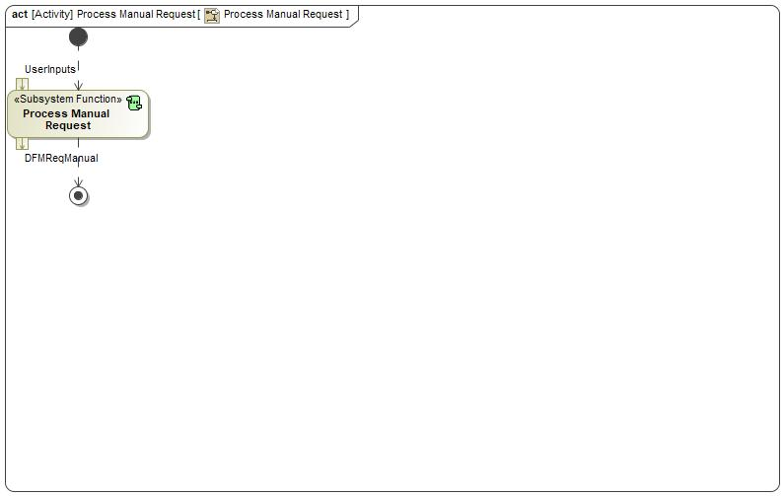

Figure 2: Activity Diagram of -1304866114.jpg “Process Manual Request” calling 1693216511.jpg “Process Manual Request”

### Function Interfaces

#### Logical Inputs

|  |  |
| --- | --- |
| **Signal Name** | **Description** |
| UserInputs  Type:  -17019447.jpg UserInputs | Received from:   * -927225563.jpg Activity Parameter Node: UserInputs |

#### Logical Outputs

|  |  |
| --- | --- |
| **Signal Name** | **Description** |
| DFMReqManual  Type:  -17019447.jpg DFMReqManual | Signal Description:  Logical signal indicating DFM is requested by user manual inputs through HMI  Sent to:   * 1693216511.jpg Determine Request |

#### Logical Parameters

*Not supported by MagicDraw report generation.*

### Function Modeling

#### Use Cases

*Not supported by MagicDraw report generation.*

#### State Charts / Activity Diagrams / Sequence Diagrams / Decision Tables

No diagrams internal to function specified.

### Function Requirements

#### Functional Requirements

##### Normal Operation

Mode - User Input No Selection

"Process Manual Request" SubSystem Function shall output "DFMReqManual = NoSelection" when the inputs are the following through HMI from users:

1) "userInDFM = NoSelection";

and 2) "userInDual = Off";

and 3) "userInTempChange = False".

|  |  |  |  |  |  |  |  |
| --- | --- | --- | --- | --- | --- | --- | --- |
| Requirement ID: | | | | | | | |
| **Rationale** |  | | | | | | |
| **Acceptance Criteria** |  | | | | | | |
| **Notes** |  | | | | | | |
| **Source** |  | | | | | **Owner** |  |
| **Source Req.** | * 1788774874.jpg DFM - Mode | | | | | **V&V Method** |  |
| **Type** |  | | | **Priority** |  | **Status** |  |
| [Req. Template](http://wiki.ford.com/display/RequirementsEngineering/Requirements+Attributes) Version | | 6.0 | End of Requirement | | | | |

Mode - User Inputs - Off

"Process Manual Request" SubSystem Function shall output "DFMReqManual = Off" when the inputs are the following through HMI from users:

1) "userInDFM = Off";

or 2) "userInDual = On";

or 3) "userInTempChange = True".

|  |  |  |  |  |  |  |  |
| --- | --- | --- | --- | --- | --- | --- | --- |
| Requirement ID: | | | | | | | |
| **Rationale** |  | | | | | | |
| **Acceptance Criteria** |  | | | | | | |
| **Notes** |  | | | | | | |
| **Source** |  | | | | | **Owner** |  |
| **Source Req.** | * 1788774874.jpg DFM - Mode | | | | | **V&V Method** |  |
| **Type** |  | | | **Priority** |  | **Status** |  |
| [Req. Template](http://wiki.ford.com/display/RequirementsEngineering/Requirements+Attributes) Version | | 6.0 | End of Requirement | | | | |

Mode - User Inputs - On

"Process Manual Request" SubSystem Function shall output "DFMReqManual = On" when the inputs are the following through HMI from users:

1) "userInDFM = On";

and 2) "userInDual = Off";

and 3) "userInTempChange = False".

|  |  |  |  |  |  |  |  |
| --- | --- | --- | --- | --- | --- | --- | --- |
| Requirement ID: | | | | | | | |
| **Rationale** |  | | | | | | |
| **Acceptance Criteria** |  | | | | | | |
| **Notes** |  | | | | | | |
| **Source** |  | | | | | **Owner** |  |
| **Source Req.** | * 1788774874.jpg DFM - Mode | | | | | **V&V Method** |  |
| **Type** |  | | | **Priority** |  | **Status** |  |
| [Req. Template](http://wiki.ford.com/display/RequirementsEngineering/Requirements+Attributes) Version | | 6.0 | End of Requirement | | | | |

##### Error Handling

No Error Handling Requirements specified.

#### Non-Functional Requirements

No Non-Functional Requirements specified.

#### Functional Safety Requirements

No Functional Safety Requirements specified.

##### ASIL Decomposition of Functional Safety Requirements

No Functional Safety Requirements with ASIL Decompositions specified.

#### Other Requirements

##### Design Requirements

No Design Requirements specified.

## 1693216511.jpg Process Vehicle Enabling Conditions

### Function Overview

#### Description

Function is allocated to:

* 1010756237.jpg Climate Controller <<Logical>>

Subsystem Function "Process Vehicle Enabling Conditions" shall set the output "DFMVehCheck" to "Pass" or "Fail" indicating the pass or fail of the vehicle conditions check, based on the input values of ambient temperature "AmbTemp", and vehicle ignition status "VehStatus" from the vehicle status system.

#### Variants

*Not supported by MagicDraw report generation.*

#### Input Requirements

*Not supported by MagicDraw report generation.*

#### Assumptions

No assumptions specified for this function.

#### References

##### Ford Documents

List here all Ford internal documents, which are directly related to the feature.

| **Reference** | **Title** | **Doc. ID** | **Revision** |
| --- | --- | --- | --- |
|  |  |  |  |

Table 5: Ford internal Documents *(not specified in model)*

##### External Documents and Publications

The list of external documents could include books, reports and online sources.

| **Reference** | **Document / Publication** |
| --- | --- |
|  |  |

Table 7: External documents and publications *(not specified in model)*

#### Glossary

See Appendix for Definitions and Abbreviations.

### Function Scope

The 1693216511.jpg **– “Process Vehicle Enabling Conditions”** function is called by the following functions:

* -1585998372.jpg – “Decide DFM Operation Mode”
* -1304866114.jpg – “Process Vehicle Enabling Conditions”



Figure 2: Activity Diagram of -1585998372.jpg “Decide DFM Operation Mode” calling 1693216511.jpg “Process Vehicle Enabling Conditions”

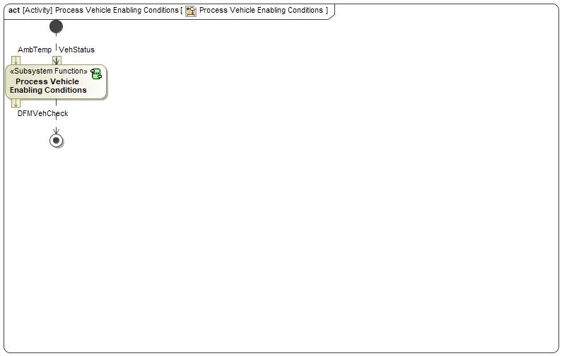

Figure 2: Activity Diagram of -1304866114.jpg “Process Vehicle Enabling Conditions” calling 1693216511.jpg “Process Vehicle Enabling Conditions”

### Function Interfaces

#### Logical Inputs

|  |  |
| --- | --- |
| **Signal Name** | **Description** |
| AmbTemp  Type:  -17019447.jpg AmbTemp | Signal Description:  Logical signal of environment temperature (in °F) as input for DFM to determine whether or not to activate  Received from:   * -927225563.jpg Activity Parameter Node: AmbTemp |
| VehStatus  Type:  -17019447.jpg VehStatus | Received from:   * -927225563.jpg Activity Parameter Node: VehStatus |

#### Logical Outputs

|  |  |
| --- | --- |
| **Signal Name** | **Description** |
| DFMVehCheck  Type:  -17019447.jpg DFMVehCheck | Signal Description:  Logical signal indicating whether vehicle level system check is passed for DFM to become On  Sent to:   * 1693216511.jpg Determine Inhibitors |

#### Logical Parameters

*Not supported by MagicDraw report generation.*

### Function Modeling

#### Use Cases

*Not supported by MagicDraw report generation.*

#### State Charts / Activity Diagrams / Sequence Diagrams / Decision Tables

No diagrams internal to function specified.

### Function Requirements

#### Functional Requirements

##### Normal Operation

Mode - Vehicle Enabling Conditions Fail

"Process Vehicle Enabling Conditions" SubSystem Function shall output "DFMVehCheck = Fail" when the inputs are the following:

1) "AmbTemb" is below DFMActicationAmbTempMin;

or 2) "ignitionStatus = Off" in "VehStatus".

|  |  |  |  |  |  |  |  |
| --- | --- | --- | --- | --- | --- | --- | --- |
| Requirement ID: | | | | | | | |
| **Rationale** |  | | | | | | |
| **Acceptance Criteria** |  | | | | | | |
| **Notes** |  | | | | | | |
| **Source** |  | | | | | **Owner** |  |
| **Source Req.** | * 1788774874.jpg DFM - Mode | | | | | **V&V Method** |  |
| **Type** |  | | | **Priority** |  | **Status** |  |
| [Req. Template](http://wiki.ford.com/display/RequirementsEngineering/Requirements+Attributes) Version | | 6.0 | End of Requirement | | | | |

Mode - Vehicle Enabling Conditions Pass

"Process Vehicle Enabling Conditions" SubSystem Function shall output "DFMVehCheck = Pass" when the inputs are the following:

1) "AmbTemb" is greater or equal to DFMActicationAmbTempMin;

and 2) "ignitionStatus = On" in "VehStatus".

|  |  |  |  |  |  |  |  |
| --- | --- | --- | --- | --- | --- | --- | --- |
| Requirement ID: | | | | | | | |
| **Rationale** |  | | | | | | |
| **Acceptance Criteria** |  | | | | | | |
| **Notes** |  | | | | | | |
| **Source** |  | | | | | **Owner** |  |
| **Source Req.** | * 1788774874.jpg DFM - Mode | | | | | **V&V Method** |  |
| **Type** |  | | | **Priority** |  | **Status** |  |
| [Req. Template](http://wiki.ford.com/display/RequirementsEngineering/Requirements+Attributes) Version | | 6.0 | End of Requirement | | | | |

##### Error Handling

No Error Handling Requirements specified.

#### Non-Functional Requirements

No Non-Functional Requirements specified.

#### Functional Safety Requirements

No Functional Safety Requirements specified.

##### ASIL Decomposition of Functional Safety Requirements

No Functional Safety Requirements with ASIL Decompositions specified.

#### Other Requirements

##### Design Requirements

No Design Requirements specified.

## -1585998372.jpg Request Air to the Desired Side

### Function Overview

#### Description

Function is allocated to:

* -443588119.jpg Climate System <<Logical>>
* -443588119.jpg DFM Feature <<Logical>>
* -443588119.jpg Users <<Logical>>
* -443588119.jpg Vehicle System <<Logical>>

Function "Adjust Air to the Desired Side" shall calculate the downstream control commands for the blower "DFM_BlowerCmd" and the FrntPsngr vent shutoff door "DFM_ShutoffDoorCmd", based on the input value of "DFMState".

#### Variants

*Not supported by MagicDraw report generation.*

#### Input Requirements

*Not supported by MagicDraw report generation.*

#### Assumptions

No assumptions specified for this function.

#### References

##### Ford Documents

List here all Ford internal documents, which are directly related to the feature.

| **Reference** | **Title** | **Doc. ID** | **Revision** |
| --- | --- | --- | --- |
|  |  |  |  |

Table 5: Ford internal Documents *(not specified in model)*

##### External Documents and Publications

The list of external documents could include books, reports and online sources.

| **Reference** | **Document / Publication** |
| --- | --- |
|  |  |

Table 7: External documents and publications *(not specified in model)*

#### Glossary

See Appendix for Definitions and Abbreviations.

### Function Scope

The -1585998372.jpg **– “Request Air to the Desired Side”** function is called by the following functions:

* -1304866114.jpg – “Adjust Air to Driver”
* -1304866114.jpg – “Adjust Air to Driver and Passenger”
* 34249308.jpg – “Request Airflow to the Desired Side”

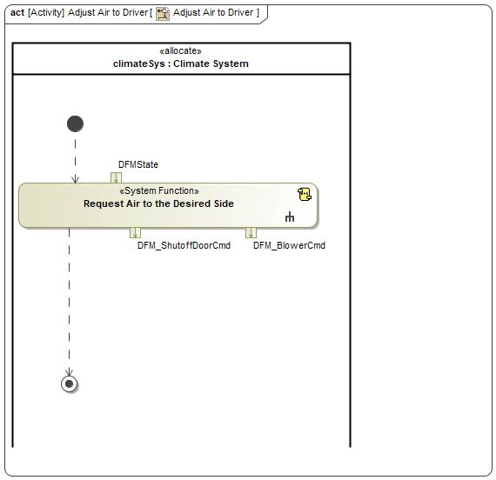

Figure 2: Activity Diagram of -1304866114.jpg “Adjust Air to Driver” calling -1585998372.jpg “Request Air to the Desired Side”

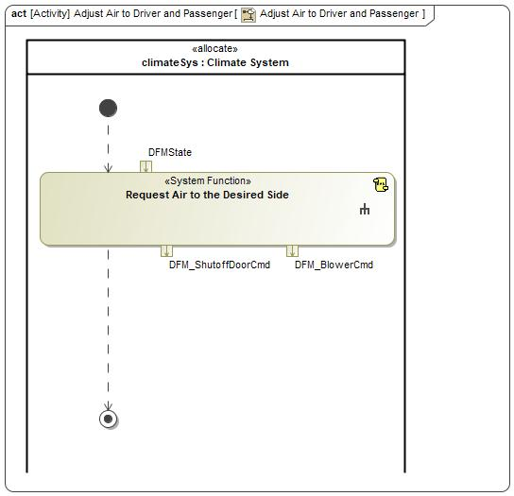

Figure 2: Activity Diagram of -1304866114.jpg “Adjust Air to Driver and Passenger” calling -1585998372.jpg “Request Air to the Desired Side”



Figure 2: Activity Diagram of 34249308.jpg “Request Airflow to the Desired Side” calling -1585998372.jpg “Request Air to the Desired Side”

### Function Interfaces

#### Logical Inputs

|  |  |
| --- | --- |
| **Signal Name** | **Description** |
| DFMState  Type:  -1346609435.jpg DFMState | Signal Description:  Logical signal of DFM ON/OFF state; On--request air to only the driver; Off--request air to both driver and passenger  Received from:   * -1585998372.jpg Decide DFM Operation Mode |

#### Logical Outputs

|  |  |
| --- | --- |
| **Signal Name** | **Description** |
| DFM_ShutoffDoorCmd  Type:  -17019447.jpg ClimateCtrlVentCmd | Signal Description:  Logical signal of the command DFM sends to the vent control for air flow adjustment both at the floor and on the instrument panel  Sent to:   * -927225563.jpg Activity Parameter Node: DFM_CmdVent |
| DFM_BlowerCmd  Type:  -17019447.jpg BlowerCmd | Signal Description:  Logical signal of the command DFM sends to the blower control for air flow adjustment  Sent to:   * -927225563.jpg Activity Parameter Node: DFM_CmdAirFlow |

#### Logical Parameters

*Not supported by MagicDraw report generation.*

### Function Modeling

#### Use Cases

*Not supported by MagicDraw report generation.*

#### State Charts / Activity Diagrams / Sequence Diagrams / Decision Tables



Figure 3: Request Air to the Desired Side

### Function Requirements

#### Functional Requirements

##### Normal Operation

DFM - Airflow

"Adjust Air to the Desired Side" system function shall output "DFM_ShutoffDoorCmd" and "DFM_BlowerCmd" based on the input value of "DFMState".

|  |  |  |  |  |  |  |  |
| --- | --- | --- | --- | --- | --- | --- | --- |
| Requirement ID: | | | | | | | |
| **Rationale** |  | | | | | | |
| **Acceptance Criteria** |  | | | | | | |
| **Notes** |  | | | | | | |
| **Source** |  | | | | | **Owner** |  |
| **Source Req.** | * 343713261.jpg DFM Transition Time * 343713261.jpg Passenger NOT Detected * 343713261.jpg User Input Received | | | | | **V&V Method** |  |
| **Type** |  | | | **Priority** | 1 - High | **Status** |  |
| [Req. Template](http://wiki.ford.com/display/RequirementsEngineering/Requirements+Attributes) Version | | 6.0 | End of Requirement | | | | |

##### Error Handling

No Error Handling Requirements specified.

#### Non-Functional Requirements

No Non-Functional Requirements specified.

#### Functional Safety Requirements

No Functional Safety Requirements specified.

##### ASIL Decomposition of Functional Safety Requirements

No Functional Safety Requirements with ASIL Decompositions specified.

#### Other Requirements

##### Design Requirements

No Design Requirements specified.

## 34249308.jpg Request Airflow to the Desired Side

### Function Overview

#### Description

Function is allocated to:

* 1207206812.jpg Driver Focused Mode <<Feature>>

"Direct Air to the Desired Side" feature function shall process various user inputs, front seat occupancy, vehicle status, and climate system status to determine the proper DFM operation mode. Based on the mode, the feature function shall output DFM feedback to HMI, a command for proper passenger side shutoff door position, and the command for proper blower speed.

#### Variants

*Not supported by MagicDraw report generation.*

#### Input Requirements

*Not supported by MagicDraw report generation.*

#### Assumptions

No assumptions specified for this function.

#### References

##### Ford Documents

List here all Ford internal documents, which are directly related to the feature.

| **Reference** | **Title** | **Doc. ID** | **Revision** |
| --- | --- | --- | --- |
|  |  |  |  |

Table 5: Ford internal Documents *(not specified in model)*

##### External Documents and Publications

The list of external documents could include books, reports and online sources.

| **Reference** | **Document / Publication** |
| --- | --- |
|  |  |

Table 7: External documents and publications *(not specified in model)*

#### Glossary

See Appendix for Definitions and Abbreviations.

### Function Scope

The 34249308.jpg **– “Request Airflow to the Desired Side”** function is called by the following functions:

* -1304866114.jpg – “Maintain Comfort while Reducing Energy Consumption”



Figure 2: Activity Diagram of -1304866114.jpg “Maintain Comfort while Reducing Energy Consumption” calling 34249308.jpg “Request Airflow to the Desired Side”

### Function Interfaces

#### Logical Inputs

|  |  |
| --- | --- |
| **Signal Name** | **Description** |
| AmbTemp  Type:  -17019447.jpg AmbTemp | Signal Description:  Logical signal of environment temperature (in °F) as input for DFM to determine whether or not to activate  Received from:   * 227346262.jpg Provide Environmental Conditions |
| VehStatus  Type:  -17019447.jpg VehStatus | Received from:   * 227346262.jpg Provide Various Vehicle Status |
| UserInputs  Type:  -17019447.jpg UserInputs | Received from:   * 227346262.jpg Provide DFM User Inputs |
| FrntPsngrStatus  Type:  -17019447.jpg FrntPsngrOccupancyStatus | Received from:   * 227346262.jpg Provide Passenger Occupancy Status |
| ClimateControlStatus  Type:  -17019447.jpg ClimateCtrlStatus | Signal Description:  Logical signal DFM receives from the climate system about purge and defrost event status  Received from:   * 227346262.jpg Provide Climate Control System Status |

#### Logical Outputs

|  |  |
| --- | --- |
| **Signal Name** | **Description** |
| DFM_CmdVent  Type:  -17019447.jpg ClimateCtrlVentCmd | Signal Description:  Logical signal of the command DFM sends to the vent control for air flow adjustment both at the floor and on the instrument panel  Sent to:   * 227346262.jpg Adjust Air Distribution - Shuttoff Door |
| DFM_CmdAirFlow  Type:  -17019447.jpg BlowerCmd | Signal Description:  Logical signal of the command DFM sends to the blower control for air flow adjustment  Sent to:   * 227346262.jpg Adjust Air Flow - Blower |
| DFMFeedback  Type:  -17019447.jpg DFMFeedback | Signal Description:  Logical signal of the command DFM sends HMI system to notify users about DFM status  Sent to:   * 227346262.jpg Display DFM Status |

#### Logical Parameters

*Not supported by MagicDraw report generation.*

### Function Modeling

#### Use Cases

*Not supported by MagicDraw report generation.*

#### State Charts / Activity Diagrams / Sequence Diagrams / Decision Tables



Figure 3: Request Airflow to the Desired Side

### Function Requirements

#### Functional Requirements

##### Normal Operation

No Normal Operation Requirements specified.

##### Error Handling

No Error Handling Requirements specified.

#### Non-Functional Requirements

No Non-Functional Requirements specified.

#### Functional Safety Requirements

No Functional Safety Requirements specified.

##### ASIL Decomposition of Functional Safety Requirements

No Functional Safety Requirements with ASIL Decompositions specified.

#### Other Requirements

##### Design Requirements

No Design Requirements specified.

# Open Concerns

**#Hint:** The following list presents open concerns, which have to be discussed or clarified over the course of the on-going requirements engineering.

| ID | Concern Description | e-Tracker / Reference | Responsible | Status | Solution |
| --- | --- | --- | --- | --- | --- |
| 1 |  |  |  |  |  |

Table 8: Open Concerns *(Not supported by MagicDraw report generation.)*

# Revision History

**#Hint:** A new version number is assigned to a document with a given revision each time it is checked in to Team Center (TCSE). After release of a revision, the document cannot be edited and no new versions can be created on that revision. When updating the document after that, a new revision has to be created and new versions on that revision will be created upon checking in.

No Revision History found.

## Template Revisions

*#Important: Do not change this section*

|  |  |  |  |  |
| --- | --- | --- | --- | --- |
| Version | Rev. | Date | Description | Responsible |
| *1* | *0* | *2016-02-26* | *Initial version, derived from FDS* | *Jbaden1* |
| *1* | *1* | *2016-02-26* | *Word properties corrected* | *Jbaden1* |
| *1* | *2* | *2016-03-10* | *Clean up of document meta data (Word properties)* | *Jbaden1* |
| *1* | *3* | *2016-03-22* | * *Footer formatting corrected (Issue 19)* * *“Constraints” chapter renamed to “Input Requirements” (Issue 20)* | *Jbaden1* |
| *1* | *4* | *2016-04-20* | * *Broken Wiki links repaired* | *Jbaden1* |
| *2* | *0* | *2016-06-10* | * *Document metadata adapted. Prepared for new macros* * *DTC table removed* * *HMI function added as a chapter (details still to be refined)* * *Signal / Parameter IDs column deleted interface tables* | *Jbaden1* |
| *2* | *1* | *2016-07-14* | * *Converted to SysML diagrams* * *HMI section further elaborated* * *Template version added to footer* * *Dedicated Startup / Shutdown sections removed (only hints added)* * *Data Dictionary reworked and Signal / Parameter IDs column re-introduced* | *Jbaden1* |
| *2* | *2* | *2016-12-07* | * *Minor formatting changes* | *Jbaden1* |
| *3* |  |  | *Skipped to synchronize with Specification_Macros.dotm* |  |
| *4* |  |
| *5* | *0* | *2017-01-13* | * *Meta data updated for specification macros, version 3.1* * *SW Unit chapter removed for the time being* * *Green boxes added for user hints* | *Jbaden1* |
| *5* | *1* | *2017-01-18* | * *Some additional hints.* * *Hyperlinks highlighted in hints* | *Jbaden1* |
| *6* | *0* | *2017-04-28* | * *Editorial change. Hints added to chapter 4.1.4* * *Chapter “Traceability Matrix” removed* | *Jbaden1* |
| *6* | *0* | *2018-04-28* | * *CR69/63: New chapters added for Functional Safety (FTTI and Technical Safety Requirements)* * *CR53: New coversheet + additional meta-data* * *CR76: merge sections for configuration and for calibration parameters into one on Function Level* | *Jbaden1* |
| *6* | *0* | *2018-08-06* | * *CR66: Fix version numbering in footer of Function Spec* | *Jbaden1* |
| *6* | *0* | *2018-09-28* | * *Broken links to RE Wiki repaired* | *Jbaden1* |
| *6* | *0* | *2018-10-31* | * *Minor corrections on cover sheet and in footer to be more GIS compliant and VSEM aligned* * *“Overview” and “Description” exchanged in headings (following common sense)* | *Jbaden1* |
| *6* | *0* | *2018-11-12* | * *Explanatory text in Variants” section revised* * *Functional Safety modifications as agreed with FuSa core team (Baseline: November 2018 Dearborn On-Site)* | *Jbaden1* |
| *M* |  | *2019-04-02* | * *Initial version of SysML report template* | *snuesch* |
| *M* |  | *2019-04-05* | * *Improved dialog boxes to select function group* | *snuesch* |
| *M* |  | *2019-04-26* | * *Improved function interfaces (support of additional elements (e.g., send signal action, add structural feature action, merge node, decision node, activity parameter nodes, etc.) and pins)* | *snuesch* |
| *N* |  | *2019-08-19* | * *For each function now also requirements satisfied by activity parameter nodes and function outputs are populated.* | *snuesch* |
| *N* |  | *2019-08-21* | * *Improved glossary and acronym tables* | *snuesch* |
| *N* |  | *2019-09-20* | * *Updated Function Interfaces tables with better wording. Added a report template variable that allows to disable senders and receivers. Sorted requirements by ID.* | *snuesch* |
| *N* |  | *2019-09-27* | * *Green hints now only show up for first function.* * *labelTag variable can be used to filter revision history.* | *snuesch* |

# Appendix

## Data Dictionary

### Logical Signals

**#Macro:** [Add Ins -> Add Requirement macro](http://wiki.ford.com/display/RequirementsEngineering/Adding+a+Logical+Signal+or+Parameter) (select “Logical Signal” as type)

AmbTemp

Logical signal of environment temperature (in °F) as input for DFM to determine whether or not to activate

|  |  |  |
| --- | --- | --- |
| **ASIL** | |  |
| **Encoding Type Name** | |  |
| Note: An encoding is either discrete or continuous. Delete fields below which are not needed | | |
| **Value**  (Continuous Encoding) | Min Value |  |
| Max Value |  |
| Resolution |  |
| Offset |  |
| **Value**  (Discrete  Encoding) |  |  |
| **Unit** | |  |

BlowerCmd

Logical signal of the command DFM sends to the blower control for air flow adjustment

|  |  |  |
| --- | --- | --- |
| **ASIL** | |  |
| **Encoding Type Name** | |  |
| Note: An encoding is either discrete or continuous. Delete fields below which are not needed | | |
| **Value**  (Continuous Encoding) | Min Value |  |
| Max Value |  |
| Resolution |  |
| Offset |  |
| **Value**  (Discrete  Encoding) |  |  |
| **Unit** | |  |

ClimateCtrlStatus

Logical signal DFM receives from the climate system about purge and defrost event status

|  |  |  |
| --- | --- | --- |
| **ASIL** | |  |
| **Encoding Type Name** | |  |
| Note: An encoding is either discrete or continuous. Delete fields below which are not needed | | |
| **Value**  (Continuous Encoding) | Min Value |  |
| Max Value |  |
| Resolution |  |
| Offset |  |
| **Value**  (Discrete  Encoding) |  |  |
| **Unit** | |  |

ClimateCtrlVentCmd

Logical signal of the command DFM sends to the vent control for air flow adjustment both at the floor and on the instrument panel

|  |  |  |
| --- | --- | --- |
| **ASIL** | |  |
| **Encoding Type Name** | |  |
| Note: An encoding is either discrete or continuous. Delete fields below which are not needed | | |
| **Value**  (Continuous Encoding) | Min Value |  |
| Max Value |  |
| Resolution |  |
| Offset |  |
| **Value**  (Discrete  Encoding) |  |  |
| **Unit** | |  |

DFMClimateCheck

Logical signal indicating whether climate system check is passed for DFM to become On

|  |  |  |
| --- | --- | --- |
| **ASIL** | |  |
| **Encoding Type Name** | |  |
| Note: An encoding is either discrete or continuous. Delete fields below which are not needed | | |
| **Value**  (Continuous Encoding) | Min Value |  |
| Max Value |  |
| Resolution |  |
| Offset |  |
| **Value**  (Discrete  Encoding) |  |  |
| **Unit** | |  |

DFMFeedback

Logical signal of the command DFM sends HMI system to notify users about DFM status

|  |  |  |
| --- | --- | --- |
| **ASIL** | |  |
| **Encoding Type Name** | |  |
| Note: An encoding is either discrete or continuous. Delete fields below which are not needed | | |
| **Value**  (Continuous Encoding) | Min Value |  |
| Max Value |  |
| Resolution |  |
| Offset |  |
| **Value**  (Discrete  Encoding) |  |  |
| **Unit** | |  |

DFMInhibit

Logical signal indicating whether DFM is inhibited

|  |  |  |
| --- | --- | --- |
| **ASIL** | |  |
| **Encoding Type Name** | |  |
| Note: An encoding is either discrete or continuous. Delete fields below which are not needed | | |
| **Value**  (Continuous Encoding) | Min Value |  |
| Max Value |  |
| Resolution |  |
| Offset |  |
| **Value**  (Discrete  Encoding) |  |  |
| **Unit** | |  |

DFMReqAuto

Logical signal indicating DFM is requested by automatic system logic

|  |  |  |
| --- | --- | --- |
| **ASIL** | |  |
| **Encoding Type Name** | |  |
| Note: An encoding is either discrete or continuous. Delete fields below which are not needed | | |
| **Value**  (Continuous Encoding) | Min Value |  |
| Max Value |  |
| Resolution |  |
| Offset |  |
| **Value**  (Discrete  Encoding) |  |  |
| **Unit** | |  |

DFMReqManual

Logical signal indicating DFM is requested by user manual inputs through HMI

|  |  |  |
| --- | --- | --- |
| **ASIL** | |  |
| **Encoding Type Name** | |  |
| Note: An encoding is either discrete or continuous. Delete fields below which are not needed | | |
| **Value**  (Continuous Encoding) | Min Value |  |
| Max Value |  |
| Resolution |  |
| Offset |  |
| **Value**  (Discrete  Encoding) |  |  |
| **Unit** | |  |

DFMRequest

Logical signal indicating DFM is requested to be On/Off regardless of method

|  |  |  |
| --- | --- | --- |
| **ASIL** | |  |
| **Encoding Type Name** | |  |
| Note: An encoding is either discrete or continuous. Delete fields below which are not needed | | |
| **Value**  (Continuous Encoding) | Min Value |  |
| Max Value |  |
| Resolution |  |
| Offset |  |
| **Value**  (Discrete  Encoding) |  |  |
| **Unit** | |  |

DFMState

Logical signal of DFM ON/OFF state; On--request air to only the driver; Off--request air to both driver and passenger

|  |  |  |
| --- | --- | --- |
| **ASIL** | |  |
| **Encoding Type Name** | |  |
| Note: An encoding is either discrete or continuous. Delete fields below which are not needed | | |
| **Value**  (Continuous Encoding) | Min Value |  |
| Max Value |  |
| Resolution |  |
| Offset |  |
| **Value**  (Discrete  Encoding) |  |  |
| **Unit** | |  |

DFMVehCheck

Logical signal indicating whether vehicle level system check is passed for DFM to become On

|  |  |  |
| --- | --- | --- |
| **ASIL** | |  |
| **Encoding Type Name** | |  |
| Note: An encoding is either discrete or continuous. Delete fields below which are not needed | | |
| **Value**  (Continuous Encoding) | Min Value |  |
| Max Value |  |
| Resolution |  |
| Offset |  |
| **Value**  (Discrete  Encoding) |  |  |
| **Unit** | |  |

FrntPsngrOccupancyStatus

|  |  |  |
| --- | --- | --- |
| **ASIL** | |  |
| **Encoding Type Name** | |  |
| Note: An encoding is either discrete or continuous. Delete fields below which are not needed | | |
| **Value**  (Continuous Encoding) | Min Value |  |
| Max Value |  |
| Resolution |  |
| Offset |  |
| **Value**  (Discrete  Encoding) |  |  |
| **Unit** | |  |

UserInputs

|  |  |  |
| --- | --- | --- |
| **ASIL** | |  |
| **Encoding Type Name** | |  |
| Note: An encoding is either discrete or continuous. Delete fields below which are not needed | | |
| **Value**  (Continuous Encoding) | Min Value |  |
| Max Value |  |
| Resolution |  |
| Offset |  |
| **Value**  (Discrete  Encoding) |  |  |
| **Unit** | |  |

VehStatus

|  |  |  |
| --- | --- | --- |
| **ASIL** | |  |
| **Encoding Type Name** | |  |
| Note: An encoding is either discrete or continuous. Delete fields below which are not needed | | |
| **Value**  (Continuous Encoding) | Min Value |  |
| Max Value |  |
| Resolution |  |
| Offset |  |
| **Value**  (Discrete  Encoding) |  |  |
| **Unit** | |  |

### Logical Parameters

**#Macro:** [Add Ins -> Add Requirement macro](http://wiki.ford.com/display/RequirementsEngineering/Adding+a+Logical+Signal+or+Parameter) (select “Logical Parameter” as type)

### Encoding Types

**#Macro:** [Add Ins -> Add Requirement macro](http://wiki.ford.com/display/RequirementsEngineering/Adding+an+Encoding+Type) (select “Encoding Type” as type)

## Glossary

**#Hint**: Terms, concepts and abbreviations used in the document shall be defined and illustrated here. Note that changes to terms and/or concepts described in this section tend to cause major updates to this document.

The tables below have feature specific definitions and abbreviations. For additional, non-feature specific terms please refer to the [RE Glossary](http://wiki.ford.com/display/RequirementsEngineering/Glossary?src=contextnavpagetreemode)

### Definitions

**#Hint:** The table below has definitions and abbreviations relevant for the functions in this document. For additional terms please refer to the [RE Glossary](http://wiki.ford.com/display/RequirementsEngineering/Glossary?src=contextnavpagetreemode)

| **Definition** | **Description** |
| --- | --- |
| airflow | The air transferred by the blower motor through HVAC ducts out of register vents into the cabin. |
| AmbTemp | Ambient Temperature, °F |
| Blower Compensation | The practice of reducing the HVAC blower motor speed to account for changes in system or HVAC behavior. |
| DFM Off | The DFM feature state when it allows airflow to both driver and front passenger based on system status. |
| DFM On | The DFM feature state when it allows airflow to only the drive side. |
| Dual | Climate control customer input for selecting separate temperature setpoints between driver & passenger zones. |
| FrntPsngr | Front Passenger |
| System | A network of interdependent components that work together to accomplish a task.  Note: Aim of an E/E system is usually a function or feature. |
| Vehicle | The overall vehicle system, including all functions, features, material, and information provided to the end user by the vehicle manufacturer as the result of a purchase. |

Table 9: Definitions used in this document

### Abbreviations

| **Abbr.** | **Stands for** |
| --- | --- |
| DFM | Driver Focused Mode; An approach to direct airflow to the driver by shutting off front passenger side duct in the HVAC system on the vehicle. |

Table 10: Abbreviations used in this document

Document ends here.